GCSE
DRAMA
Revision Guidance

CONTENTS PAGE

The course outline | p.2
Exam dates | p.3
Textbooks and revision guides | p.4
Exam paper | p.3
What do I need to revise | p.4
KS4 Schedule | p.5
Blood Brothers Revision | p.6

Course Details.

The Drama course you are studying is with AQA and the qualification is made up of three different components. You will learn through experience, seeing theatre and making theatre for yourselves. You will be introduced to a wide range of theatrical styles and contexts as you explore plays practically, devise and work on performances
You will complete 2 practical exams during the course and a written exam in June 2018.

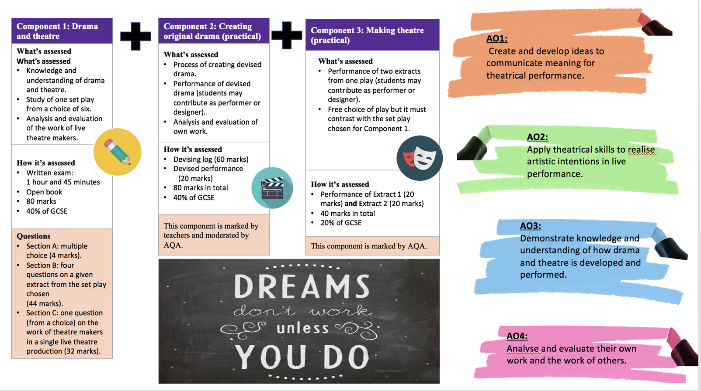Exam Dates.
Paper Title | Length/ Time | Marks | Worth | Date
Component1  Understanding Drama  WRITTEN EXAMINATION | 1 hour and 45 minutes | 80 | 40% of your final grade | Friday 18th May 2020  pm
Component 2  Devising Drama |  | 20 | 40% of your final grade | Practical  July 2019
 |  | 60 |  | Devising Log  Monday 24th February 2020
Component 3 – Texts in practice |  | 40 | 20% of your final grade | Practical – External examiner  6th – 7th February 2020

Blood Brothers by Willy Russell
Blood Brothers: CGP Play Guide
GCSE Bitesize Drama
GCSE DRAMA: CGP
Textbooks and Revision Guides

Component 1 – Written paper
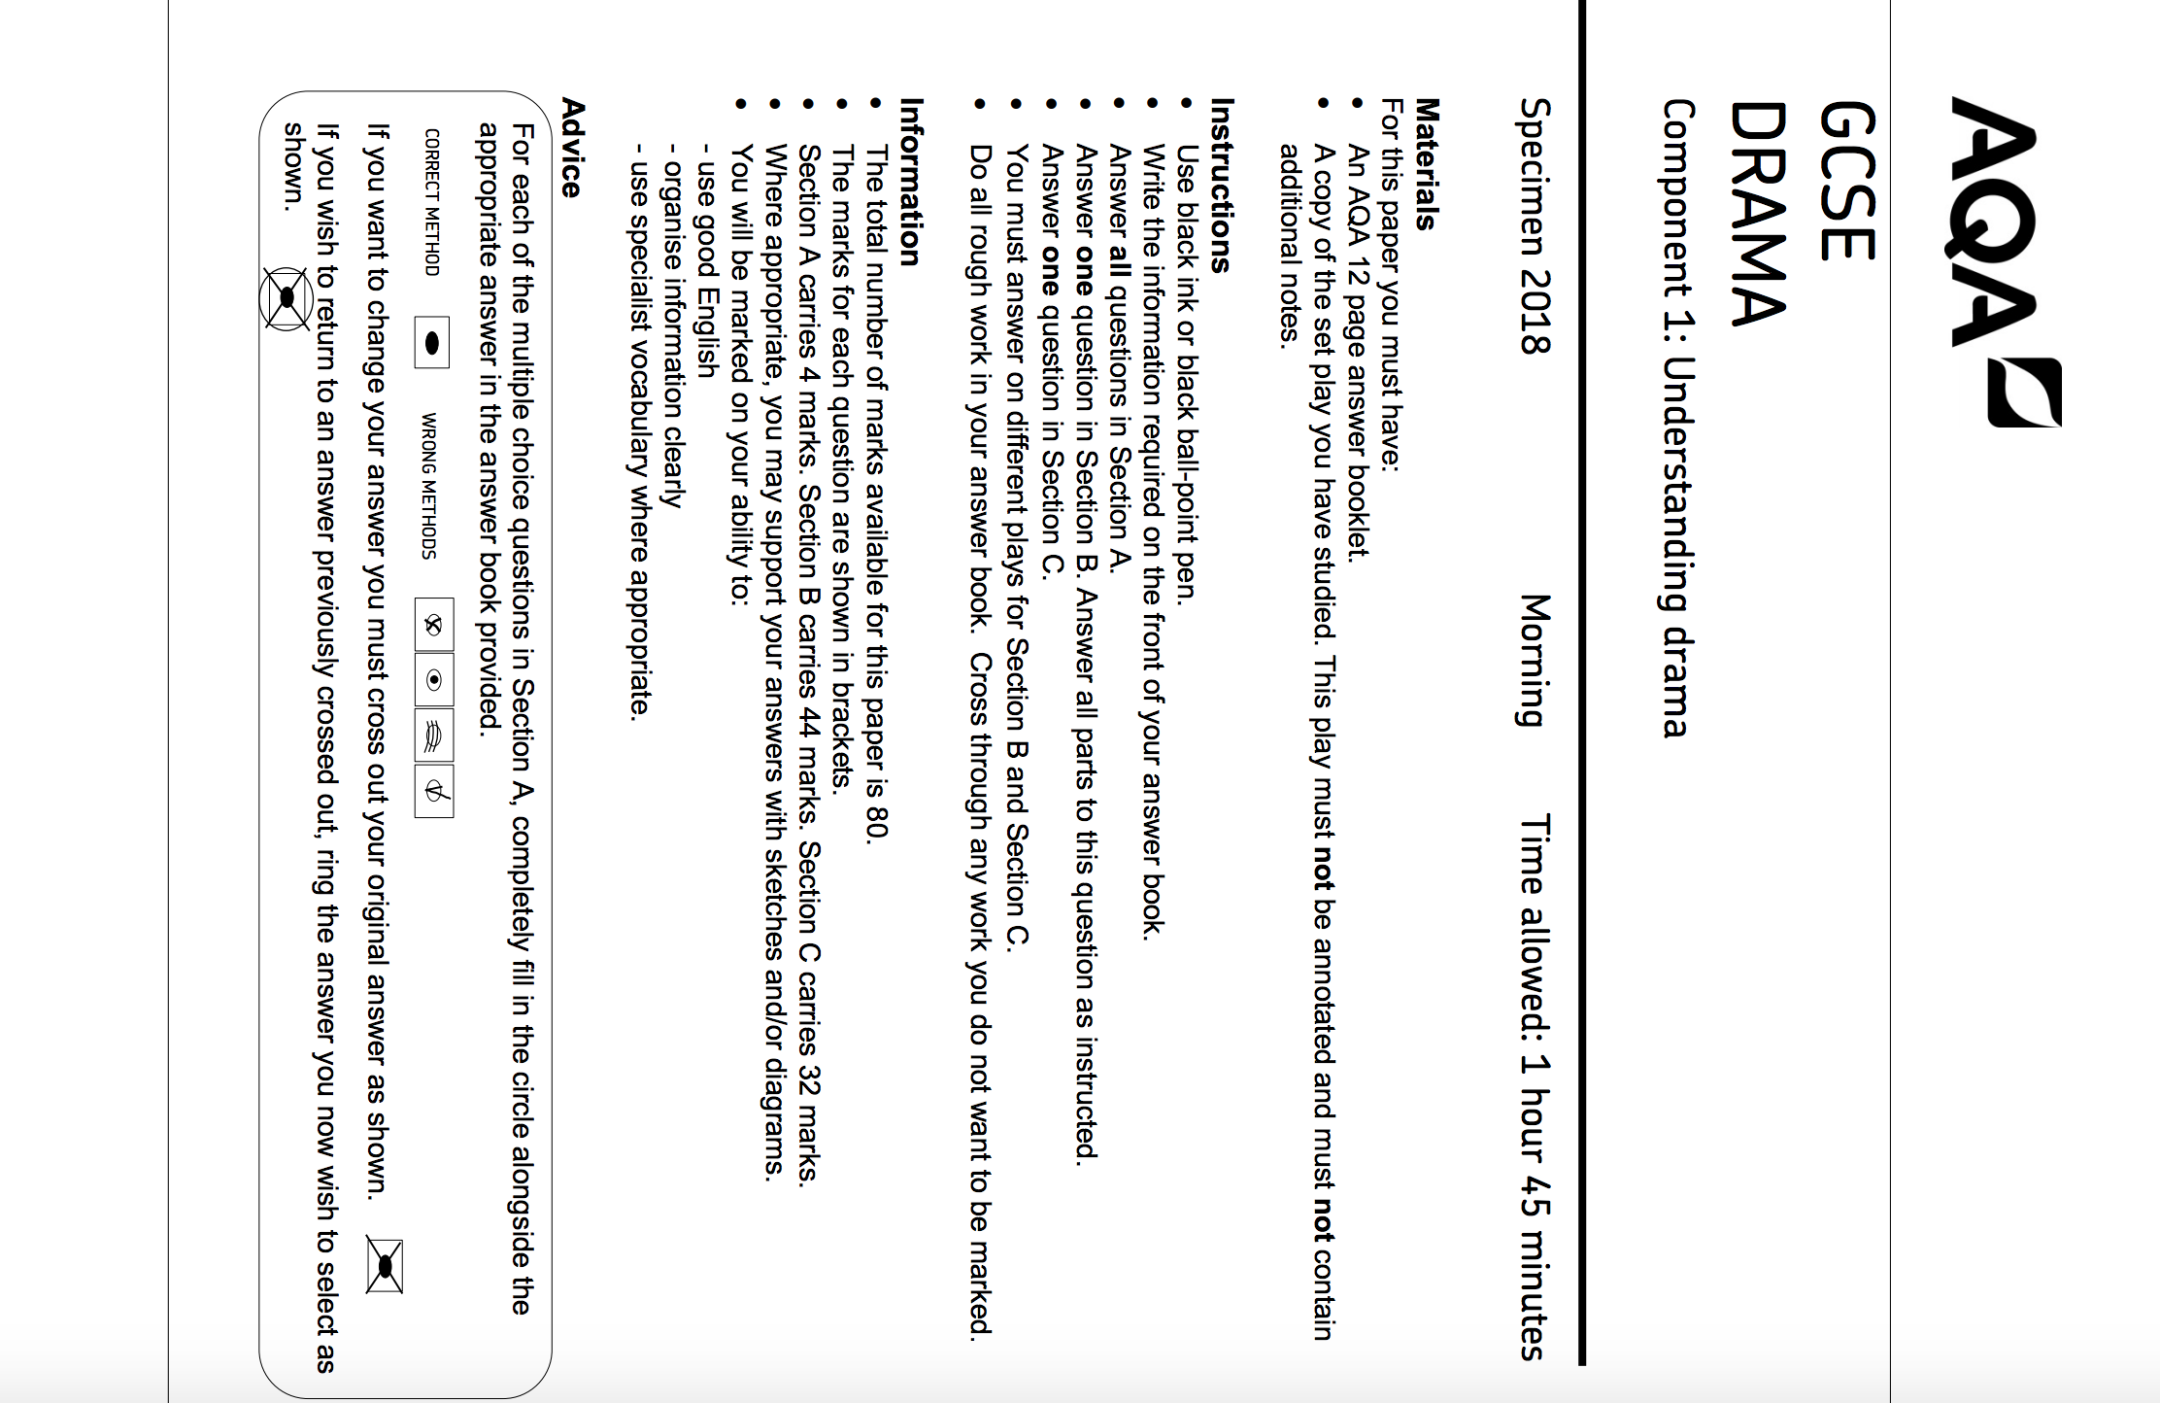
- Use black ink or black ball-point pen.
- Write the information required on the front of your answer book.
- Answer all questions in Section A.
- Answer one question in Section B.
- Answer all parts to this question as instructed.
- Answer one question in Section C.
- You must answer on different plays for Section B and Section C.
- Do all rough work in your answer book.
- Cross through any work you do not want to be marked.

SECTION A – Theatre Roles and Terminology  Answer all 4 questions  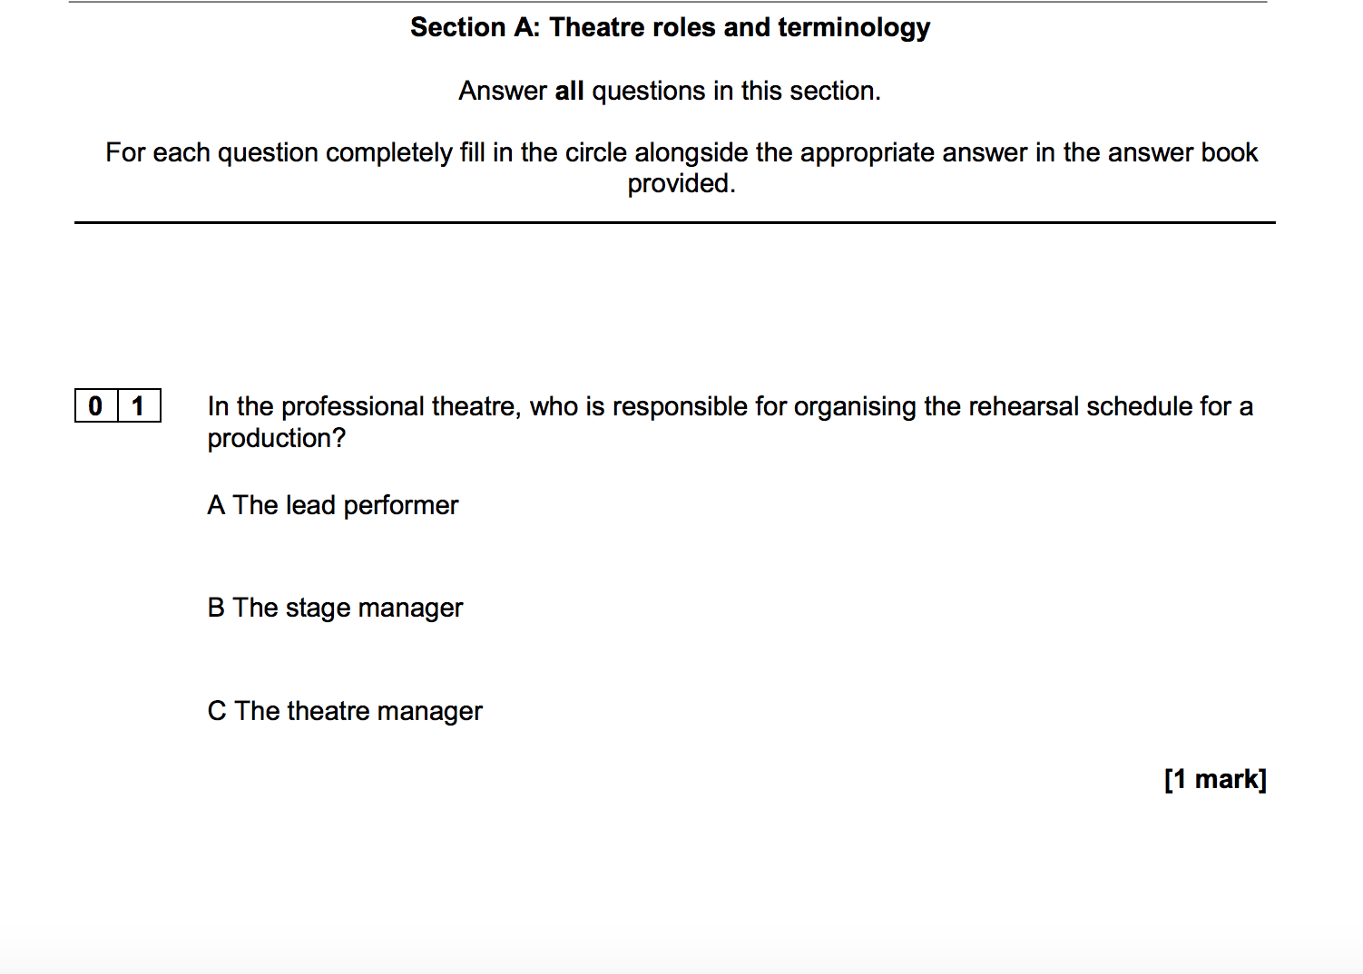 | SECTION B – Blood Brothers  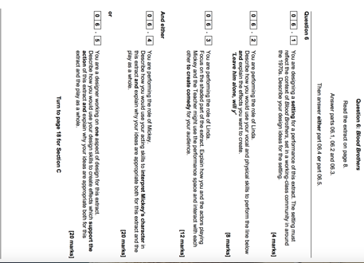  Choose either 4 OR 5  You must answer questions 1,2,3
Answer 1 question only
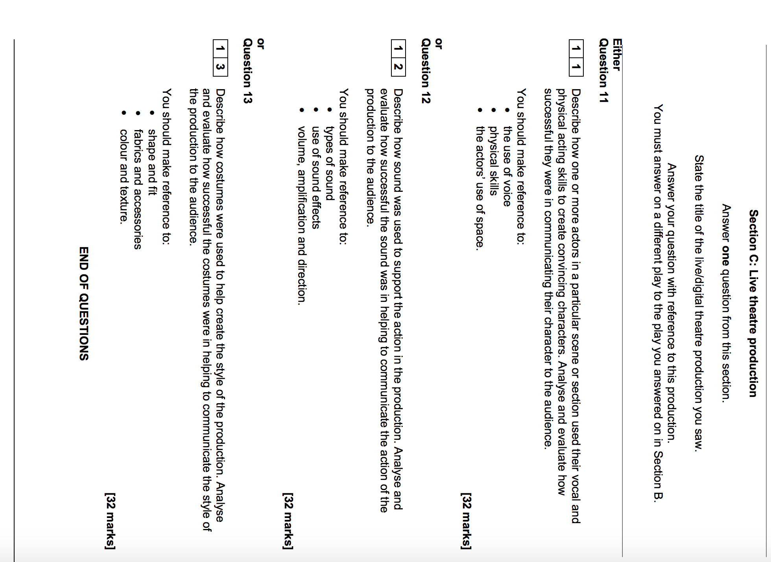
SECTION C –Live Theatre
What do I need to revise for the written paper?
SECTION A | SECTION B | SECTION C
Theatre roles and Terminology  - Glossary of theatrical terms  - Stage positions  - Roles in the theatre  - Stage types | Blood Brothers – Willy Russell  - Characters  - Design  - Costume/props  - Lighting/SFX  - Historical and social context  - Style and genre | Live Theatre  - The perceived aims and success of the production team.  - Research the chosen play  - Collaboration of performers and directors and designers  - Audience experience and response

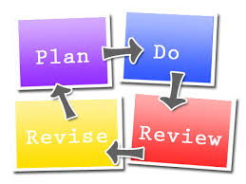

KS4 Schedule for Drama Yr.11
SCHEDULE: Y11 Drama
