GCSE
Citizenship
Revision Guidance
Course Details
The Citizenship course you are studying is with AQA and the qualification is made up of four different units. There are two exams, with two units in each. You will sit the exams at the end of Year 11, and details of the units you will study are below:

Paper | Topics | Length/  time | Marks | Worth
Paper 1 | Section A: Active citizenship  Section B: Politics and participation | 1 hour  45 mins | 80 | 50%
Paper 2 | Section A: Life in modern Britain  Section B: Rights and responsibilities | 1 hour  45 mins | 80 | 50%

Textbooks and Revision Guides
All books available from online book shops such as Amazon.
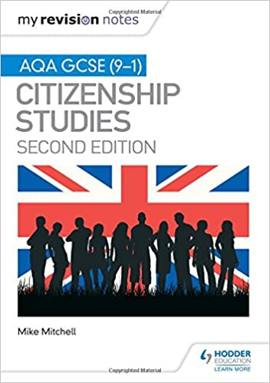
My Revision Notes: AQA GCSE (9-1) Citizenship Studies Second Edition
by Mike Mitchel

Hodder Education
ISBN: 978-1-5104-1830-1

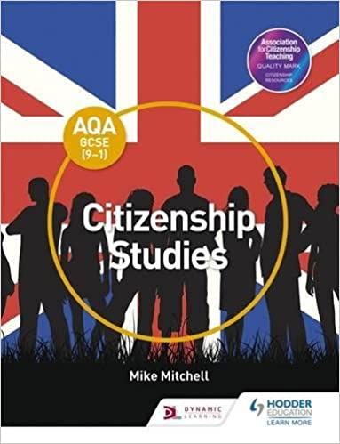
AQA GCSE (9–1) Citizenship Studies (Aqa Gcse Citizenship) Paperback
by Mike Mitchell

Hodder Education
ISBN: 978-147-1-86493-3

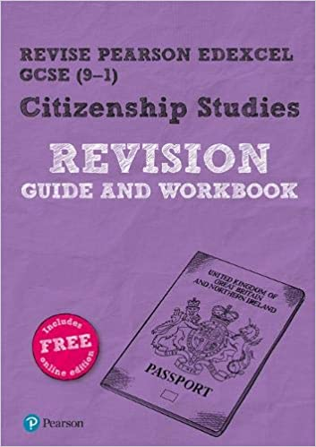
Revise Pearson Edexcel GCSE (9-1) Citizenship Studies Revision Guide & Workbook
By Graeme Roffe

Pearson
ISBN: 978-1292268163

What do I need to revise?
Paper 1: Politics and Participation

Where does political power reside in the UK and how is it controlled?

1. Definitions for democracy including representative democracy and direct democracy
2. The values that underpin democracy in the UK by giving examples of:
- The rights we have i.e. to freedom of speech
- Responsibilities i.e. to vote
- Freedoms i.e. of religion
- The rule of law i.e. no one is above the law
3. Why these things are so important.
4. The institutions of the British constitution. What they are and what their roles are:
- Power of government
- The Prime Minister and cabinet
- The sovereignty of Parliament
- The roles of the legislature
- The opposition
- Political parties
- The Monarch
- Citizens
- The judiciary
- The police
- The Civil Service
5. Explanation how what it means to have an uncodified constitution and how this has changed in recent years.

What are the powers of local and devolved governments?

1. Role and structure of elected local government, including the services provided i.e. planning.
2. Roles and accountability of councillors.
3. The nature and organisation of regional and devolved governments in Scotland, Wales, Northern Ireland and England.
- Names of government buildings
- Leaders
- Brief history
4. How powers are organised between Westminster Parliament and the devolved governments in Northern Ireland, Scotland and Wales i.e. what powers do the devolved governments have?
5. How the relations change between England, Scotland, Wales and Northern Ireland i.e. Scottish Independent vote and Brexit impacting on Northern Ireland.
6. Who can stand for election and how candidates are selected.
7. Who can and cannot vote in elections and why.
8. Debates for and against lowering the voting age.
9. Reasons for why people may not vote in elections and suggestions for how to improve voter turnout.
10. How public taxes are raised and spent by the government locally and nationally.
11. How the government budgets and makes decisions about where money should be spent.
12. Different views and debates about how governments and other service providers make provision for welfare, health (NHS), the elderly and education.

Where does political power reside?

1. Explanation of what First Past the Post is and how often a general election is.
2. Other voting systems used in UK elections, including proportional representation and the advantages and disadvantages of each. This includes:
- Closed party list
- Additional members system
- Supplementary votes
- Single transferrable vote
3. The difference between:
- The executive
- The legislature
- The judiciary
- The monarchy
4. What a bicameral Westminster parliament is, and the roles and the relationship between the House of Commons and the House of Lords and the role of the monarch.
5. The major political parties in the UK (Conservative, Labour, Lib Dems).
- Key philosophical differences between them
6. How parliament works:
- Scrutinising government and making it accountable
- Parliamentary questions
- Committees
- Debates
7. The role of Members of Parliament (MPs):
- Representing their constituencies
- Debating policy
- Scrutinising legislation
8. Ceremonial roles in Parliament and what they do:
- Black Rod
- The Speaker
- Whips
- Front ben and back bench MPs
9. The legislative process:
- Parliamentary debates and deliberation of public issues and policy.
10. The formation of the government by the leader of the political party with a majority in the House of Commons, or by a coalition of parties.
11. Role of the Prime Minister, cabinet and ministers including the power they have.
12. The organisation of government administration into departments, ministries and agencies including the role of the civil service.

How do others govern themselves?

1. Electoral systems and the processed used in European parliamentary elections; the impact of these systems on the makeup of political parties representing citizens.
2. Key differences in how citizens can or cannot participate in politics in one democratic and on non – democratic political system that is outside the UK (i.e. USA and North Korea).

How can citizens bring about political change?

1. How citizens can contribute to parliamentary democracy and hold those in power to account.
2. How digital democracy, social media and other measures are being developed as a means to improve voter engagement and the political participation from citizens.
3. How citizens can hold those in power to account for their actions by:
- Joining an interest group or political party
- Standing for election
- Campaigning
- Advocacy
- Lobbying
- Petitions
- Joining a demonstration
- Volunteering
4. The roles played by public institutions, public services, interest and pressure groups, trade unions, charities and voluntary groups in giving a voice and support for different groups in society.

Paper 2: Life in Modern Britain

Principles and values that underpin British Society

- The key principles and values underpinning British society today.
- The rights we have i.e. to freedom of speech
- Responsibilities i.e. to vote
- Freedoms i.e. of religion
- The rule of law i.e. no one is above the law
2. The human, moral, legal and political rights and the duties, equalities and freedoms of citizens.
3. Key factors that create individual, group, national and global identities i.e. religion, ethnicity.

What do we mean by identity?

1. The United Kingdom of Great Britain and Northern Ireland is comprised of England, Northern Ireland, Scotland and Wales. The impact of this on identity debates.
2. Changes and movement of population over time i.e. why people moved after WW2 and why people moved after European Union expansion in 2004.
3. The impact on different communities in the UK i.e. increased number of specialist shops.
4. The nature of immigration and migration to and from the UK.
5. What creates identity and multiple identities;
6. The diverse nature of the UK population through ethnicity, religion, culture.

What is the role of the free press?

- The rights, responsibilities and role of the media and a free press in:
- informing and influencing public opinion
- providing a forum for the communication and exchange of ideas and opinions
- holding those in power to account.
2. The right of the media to investigate and report on issues of public interest subject to the need for accuracy and respect for people's privacy and dignity i.e. the expenses scandal and phone hacking inquiry.
3. The operation of press regulation and examples of where censorship is used.

What is the UK’s role in key international organisations?

- The role of the UK within:
- the United Nations (UN),
- NATO,
- the European Union (EU),
- the Council of Europe,
- the Commonwealth and
- the World Trade Organisation (WTO).
2. The UK’s membership of the EU and its impact upon the UK.
3. How the UK has assisted in resolving international disputes and conflicts, and the range of methods used i.e. use of force, mediation, sanctions.
4. How non-governmental organisations (NGOs) respond to humanitarian crises i.e. Syrian refugee crisis or Haiti Earthquake.

How citizens make their voice heard and make a difference in society

1. The opportunities and barriers to citizen participation in democracy.
2. The range of actions a citizen can take who wishes to hold those in power to account and the advantages and disadvantages of:
- joining an interest group or political party,
- standing for election,
- campaigning,
- advocacy,
- lobbying,
- petitions,
- joining a demonstration
- volunteering.
- The role of organisations such as;
- public services,
- interest groups,
- pressure groups,
- trade unions,
- charities
- voluntary groups and how they play a role in providing a voice and support for different groups in society.
4. Two different examples of how citizens working together, or through groups, attempt to change or improve their communities through actions to either address public policy, challenge injustice or resolve a local community issue i.e. Loose Ends and Community Youth Project.
5. How those who wish to bring about change use the media.

Paper 2: Rights and Responsibilities

What laws does a society require and why?

1. The fundamental principles of law to ensure rights and freedoms, the presumption of innocence and equality before the law.
2. The nature of rules and laws in helping society to deal with complex problems of fairness, justice and discrimination.
3. Rights in local to global situations where there is conflict and where rights and responsibilities need to be balanced.

What are a citizen’s rights and responsibilities within the legal system?

- The operation of the justice system:
- the role and powers of the police
- the role and powers of the judiciary
- the roles of legal representatives
- how the different criminal and civil courts work
- tribunals and other means of dispute resolution.
2. Rights and legal entitlements of citizens at differing ages: the age of criminal responsibility and other legal ages when young people become legally responsible for their actions (drive, marry, vote, join the forces).
3. How civil law differs from criminal law.
4. How the legal systems differ within the UK:
- England and Wales
- Northern Ireland
- Scotland.

How has the law developed over time, and how does the law protect citizens and deal with criminals?

1. How citizens' rights have changed and developed over time, from the importance of Magna Carta (1215) to today and the Human Rights Act (1998).
2. Common law, legislation and how they differ.
3. The right to representation;
4. The role and history of trade unions in supporting and representing workers;
5. The role of employers’ associations.
6. The nature of criminality in the UK today:
- differing types of crimes
- profile of criminality in the UK
- factors affecting crime rates in society and strategies to reduce crime.
7. How we deal with those who commit crime:
- differing forms of punishment available in the UK
- the purposes of sentencing
- the effectiveness of differing types of sentence
- how the youth justice system operates.

What are the universal human rights and how do we protect them?

- The importance of key international agreement and treaties in regard to human rights:
- the UN Universal Declaration on Human Rights
- the European Convention on Human Rights
- the UN Convention on the Rights of the Child
- the Human Rights Act (1998).
- The role of international law in conflict situations:
- to protect victims of conflict
- how international humanitarian law helps establish the rules of war.

How do citizens play a part to bring about change in the legal system?

- You need to understand the roles undertaken by citizens within the legal system and how the role of the citizen has been seen to be pivotal to our justice system. You should understand the responsibilities and roles of citizens in the legal system;
- as a juror, witness,
- a victim of crime,
- magistrate,
- special constable,
- police commissioner
- member of a tribunal hearing.
- The roles played by:
- pressure and interest groups,
- trade unions,
- charities and voluntary groups,
- public institutions and public services in providing a voice and support for different groups in society campaigning to bring about a legal change or to fight an injustice.
- You should be aware of the different forms of democratic and citizenship actions people can take to bring about change and hold those in positions of power to account in regard to issues relating to human rights and the justice system:
- joining an interest group;
- campaigning;
- advocacy;
- lobbying;
- petitions;
- joining a demonstration;
- volunteering.

