GCSE Computing

Revision Guide

Contents
The course outline 2
Assessment overview 2
Exam dates 2
Useful Websites 3
Revision guides 3
What do I need to revise for Computer systems (01) 4
What do I need to revise for Computational thinking, algorithms and programming (02) 8
GCSE Computing Timeline 11
Command Words for the exams 12
Tackling Essay Questions 13
Flowchart symbols 14

GCSE Computer Science Revision Guidance

The course outline
Component 01: Computer systems
Introduces students to the central processing unit (CPU), computer memory and storage, wired and wireless networks, network topologies, system security and system software. It also looks at ethical, legal, cultural and environmental concerns associated with computer science.
Component 02: Computational thinking, algorithms and programming
Students apply knowledge and understanding gained in component 01. They develop skills and understanding in computational thinking: algorithms, programming techniques, producing robust programs, computational logic, translators and data representation.

Assessment overview
Content Overview | Assessment Overview
Computer systems  - Systems Architecture  - Memory  - Storage  - Wired and wireless networks  - Network topologies, protocols and layers  - System security  - System software  - Ethical, legal, cultural and environmental concerns | Computer systems (01)  80 marks  1 hour and 30 minutes  Written paper  (no calculators allowed) | Worth 50% of total GCSE
Computational thinking, algorithms and programming  - Algorithms*  - Programming techniques  - Producing robust programs  - Computational logic  - Translators and facilities of languages  - Data representation | Computational thinking, algorithms and programming (02)  80 marks  1 hour and 30 minutes  Written paper  (no calculators allowed) | Worth 50% of total GCSE

Exam dates
TBC Computer systems AM 1h 30m
TBC Computational thinking, algorithms and programming PM 1h 30m

Useful Websites
https://www.senecalearning.com/
http://ocr.org.uk/qualifications/gcse-computer-science-j276-from-2016/
https://www.cambridgegcsecomputing.org/
https://mrcolley.com/ict-computing-resources/gcse-computer-science/

Revision guides
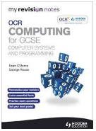  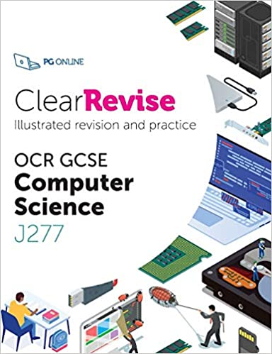 | My Revision Notes OCR Computing for GCSE Computer Systems and Programming  ClearRevise OCR GCSE Computer Science
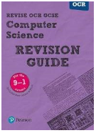 | Revise OCR GCSE (9-1) Computer Science Revision Guide
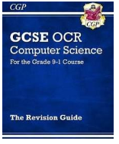 | New GCSE Computer Science OCR Revision Guide - For the Grade 9-1 Course

What do I need to revise for Computer systems (01)
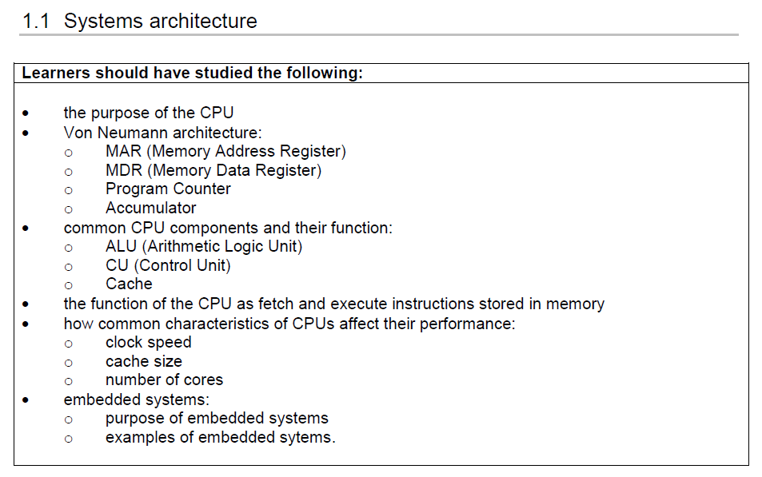
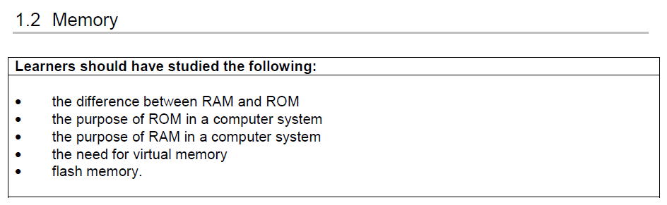
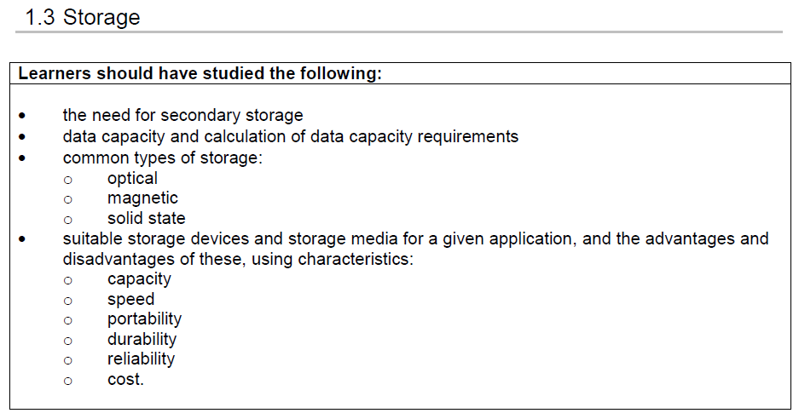
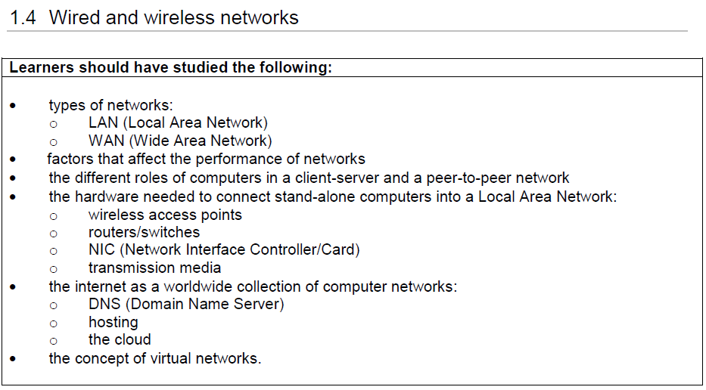
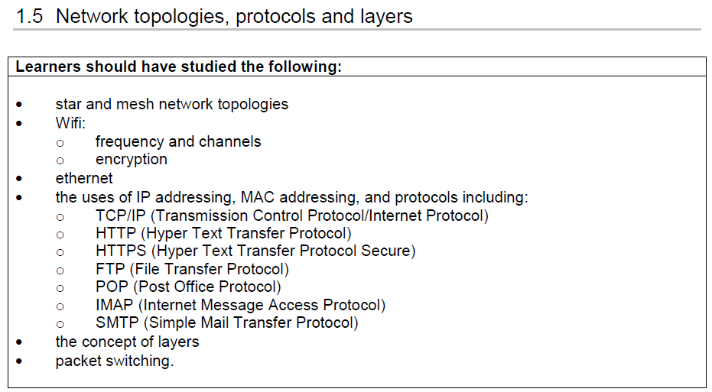
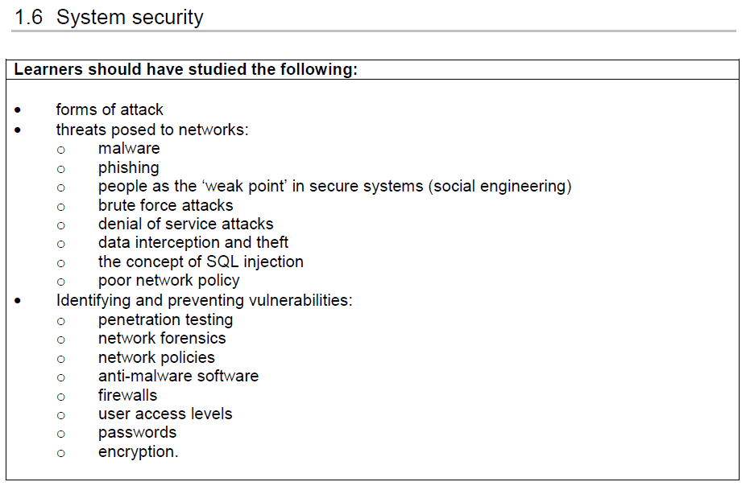
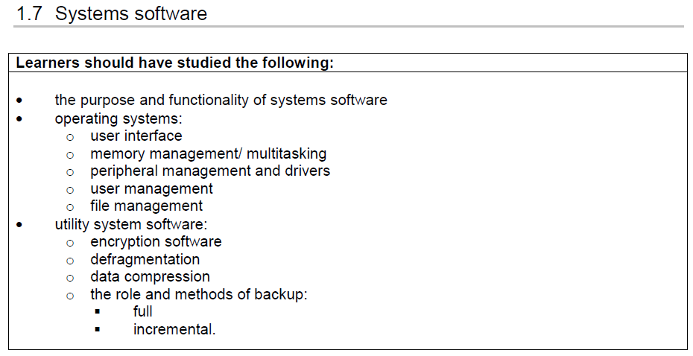
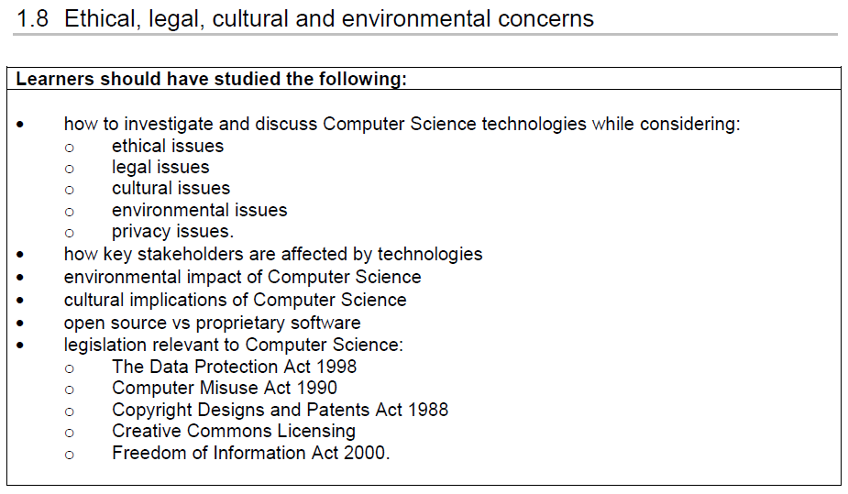

What do I need to revise for Computational thinking, algorithms and programming (02)
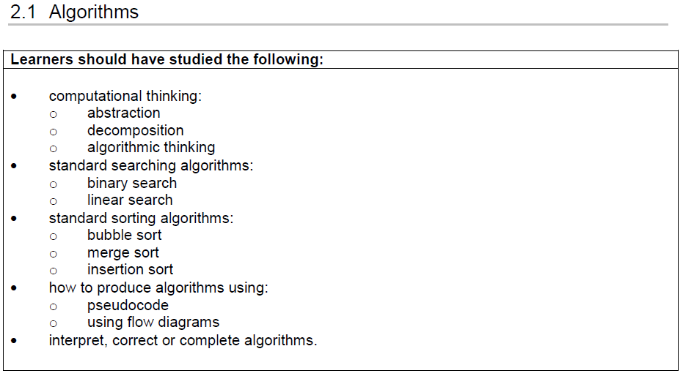
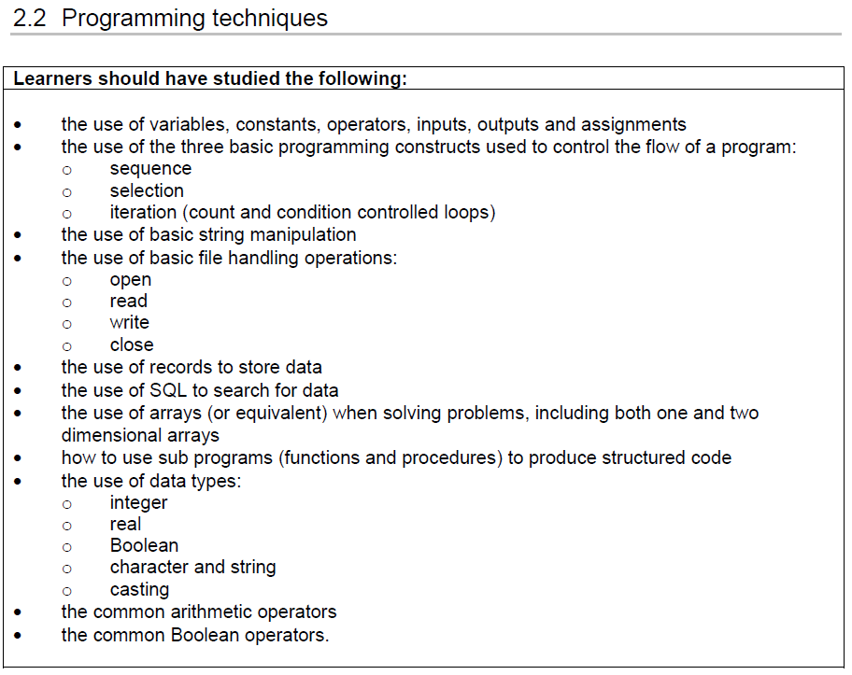
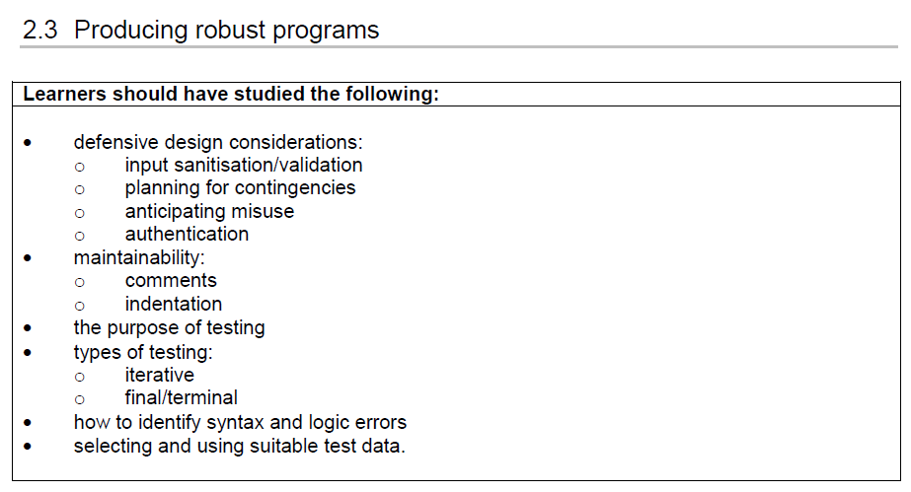
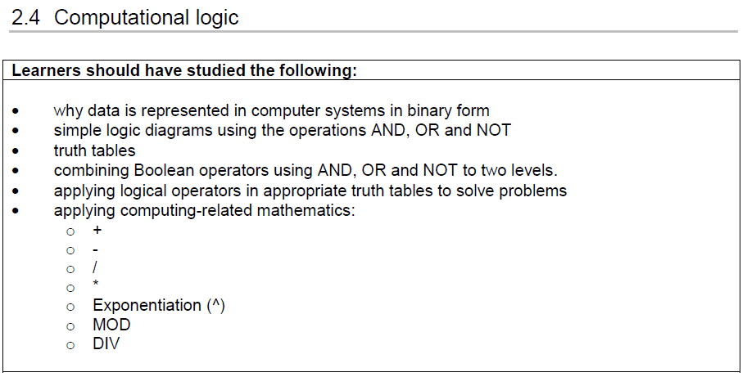
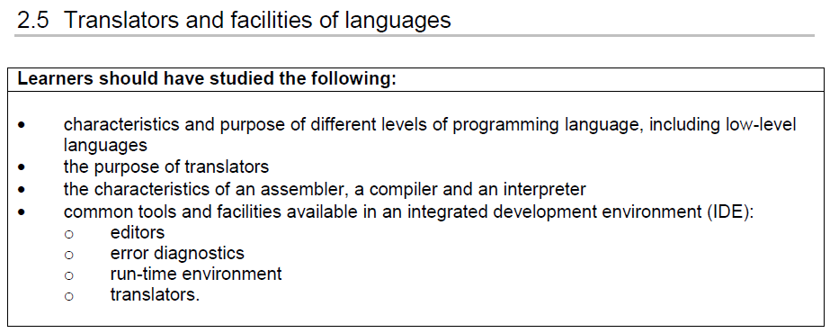
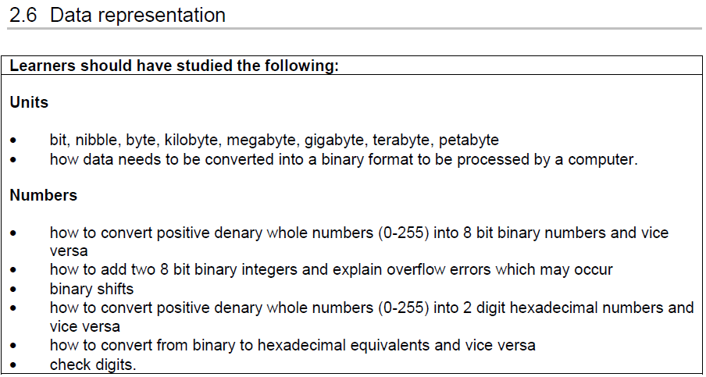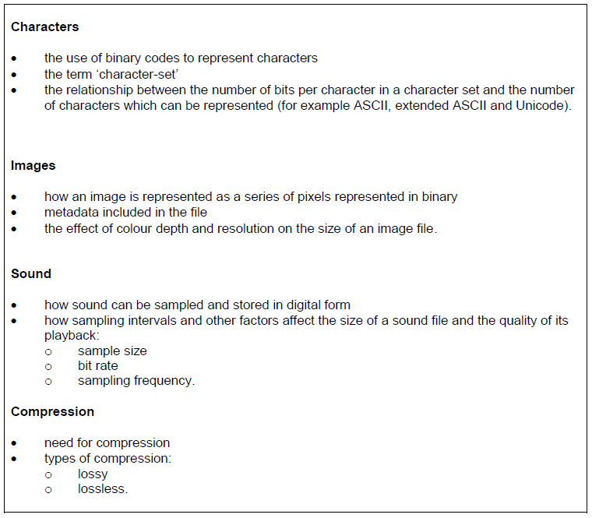

Command Words for the exams
Command words | Meaning
Add | Join something to something else so as to increase the size, number, or amount.
Annotate | Add brief notes to a diagram or graph.
Calculate | Obtain a numerical answer showing the relevant stages in the working.
Complete | Provide all the necessary or appropriate parts.
Convert | Change the form, character, or function of something.
Define | Give the precise meaning of a word, phrase, concept or physical quantity.
Design | Produce a plan, simulation or model.
Draw | Produce (a picture or diagram) by making lines and marks on paper with a pencil, pen, etc.
Give | Present information which determines the importance of an event or issue. Quite often used to show causation.
Outline | Give a brief account or summary.
How | In what way or manner; by what means.
Identify | Provide an answer from a number of possibilities. Recognise and state briefly a distinguishing factor or feature.
Label | Add title, labels or brief explanation(s) to a diagram or graph.
List | Give a sequence of brief answers with no explanation.
Order | Put the responses into a logical sequence.
Outline | Give a brief account or summary.
Show | Give steps in a derivation or calculation.
Solve | Obtain the answer(s) using algebraic and/or numerical and/or graphical methods.
State | Give a specific name, value or other brief answer without explanation or calculation.
Tick | Mark (an item) with a tick or select (a box) on a form, questionnaire etc. to indicate that something has been chosen.
What | Asking for information specifying something.

Tackling Essay Questions
It is important when revising for essay-style examinations that you are familiar with the wording that may be used for the question.
Command words | Meaning
Analyse | Break down in order to bring out the essential elements or structure. To identify parts and relationships, and to interpret information to reach conclusions.
Compare | Give an account of the similarities and differences between two (or more) items or situations, referring to both (all) of them throughout.
Describe | Give a detailed account or picture of a situation, event, pattern or process
Differentiate | Explore and explain the differences.
Discuss | Offer a considered and balanced review that includes a range of arguments, factors or hypotheses. Opinions or conclusions should be presented clearly and supported by appropriate evidence.
Evaluate | Assess the implications and limitations; to make judgements about the ideas, works, solutions or methods in relation to selected criteria.
Explain | Give a detailed account including reasons or causes.
Justify | Give valid reasons or evidence to support an answer or conclusion.

Try to use the following writing frame as a ‘recipe’ to construct your answer so that you are presenting a balanced view point that meets mark band 3.
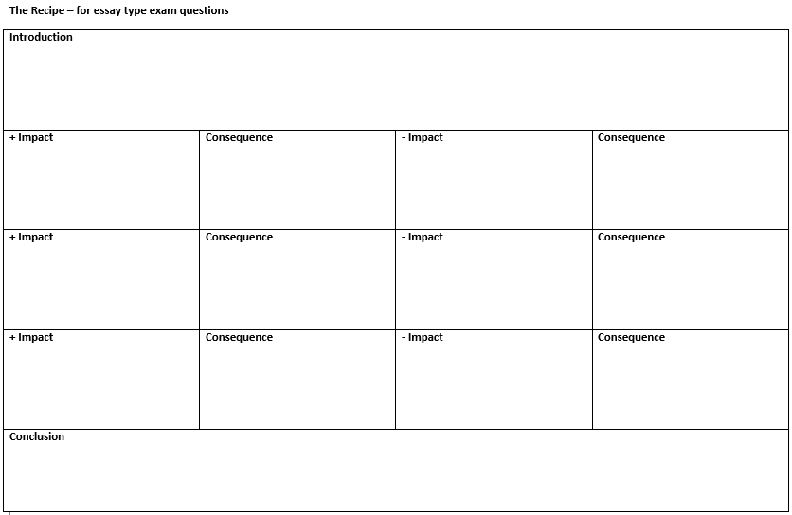

Flowchart symbols
