Revision Guidance
Science

CONTENTS PAGE

The course outline | p.3 – 6
Textbooks and revision guides | p.7
Effective revision | p.8
List of content to revise | p. 9

Course Details.
Most students will be entered for GCSE combined science and will achieve a double GCSE grade (from 1-1 to 9-9). Some students will be put onto the separate science pathway and will achieve three GCSEs in biology, chemistry and physics.
Examination board and specification: AQA GCSE Combined Science: Trilogy (8464)
AQA GCSE Biology (8461)
AQA GCSE Chemistry (8462)
AQA GCSE Physics (8463)
GCSE combined science
Students have been taught biology, chemistry and physics topics and will take six examination papers as outlined below. The list of topics will be useful to students when revising.
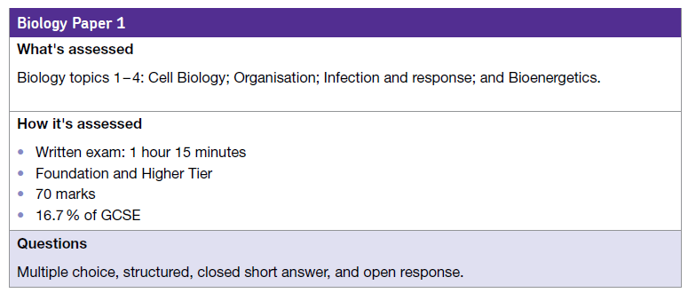
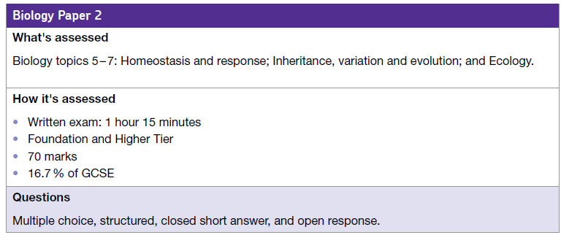
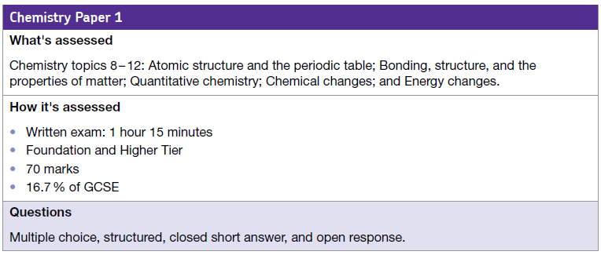

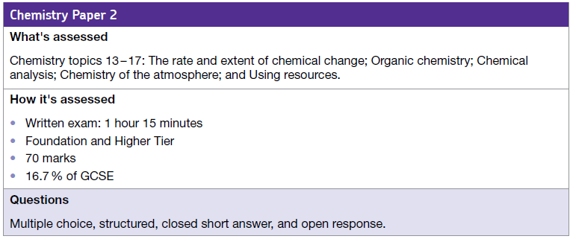

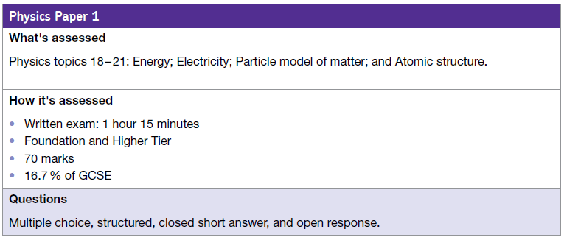
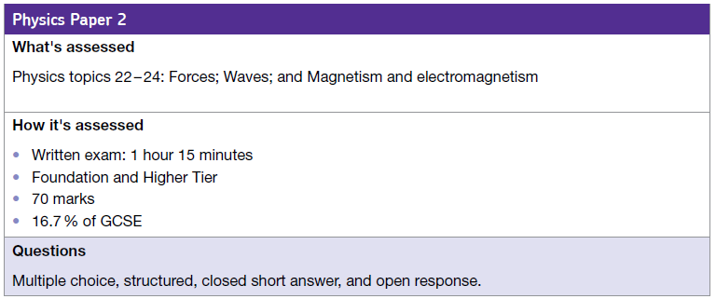
Tier of entry
A student’s teacher will decide which tier of entry students are entered for in examinations. It is not possible to mix tiers of entry. We will make this decision based on the tier we think will give the student the highest grades.

Students on the foundation tier can be awarded grades of 1-1 to 5-5.
Students on higher tier can be awarded grades of 3-4 to 9-9. Students who do not achieve enough marks to achieve 3-4 will be recorded as U (unclassified).

Required practical work
The GCSE is 100% examination based BUT students will have completed twenty one required practical activities throughout the course. The examinations will test students’ knowledge and understanding of these activities and their ability:

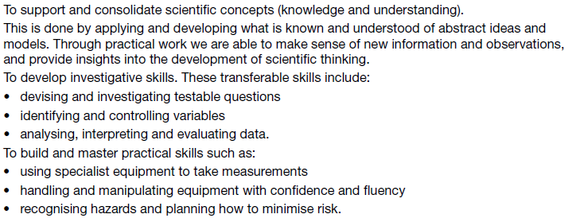
GCSE biology, GCSE chemistry and GCSE physics
Students on this pathway achieve three GCSEs – a separate GCSE for each science discipline. They also take six examinations but are examined on extra content. The format for these examinations, and topic lists, is found on the following pages. Most on this pathway will be entered for the higher tier examination papers.
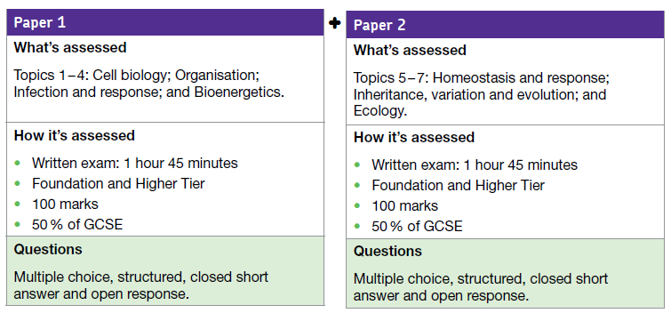
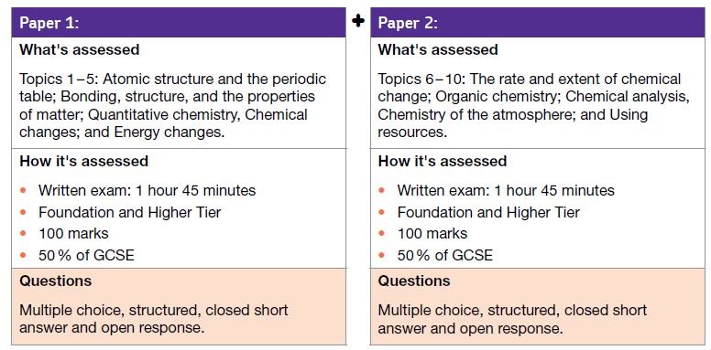
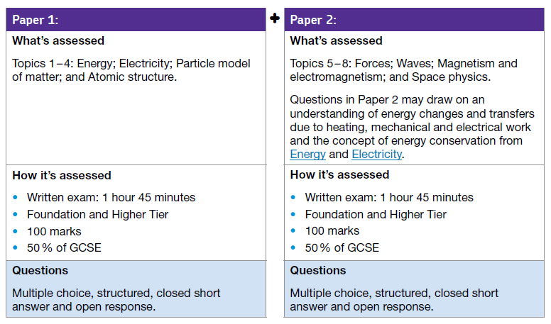
Textbooks and Revision Guides.
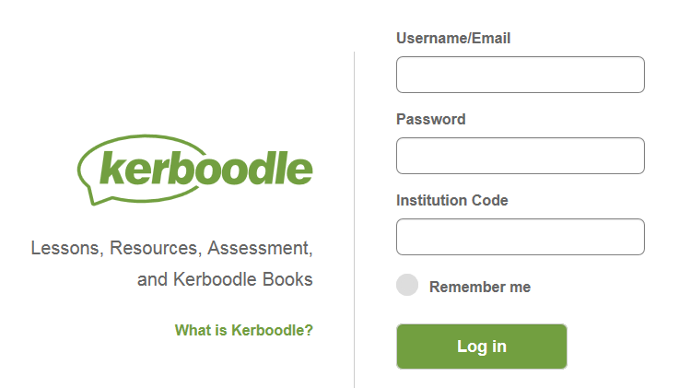
All students have access to a course specific website called Kerboodle. Students should be aware of this.
Kerboodle will help students to revise and includes all content that they need to know.
There is an online text book, with revision questions and answers, and access to quizzes/activities.
Go to https://www.kerboodle.com/users/login and login - the screen should look like the one on the right.
The username is a student’s first initial followed by the surname. E.g. jsmith
The password is the same as the username for the first login – students will then be asked to change the password.
The institution code is oy5.
Students should see Miss Marson if you need support logging into Kerboodle.
We have offered students the chance to purchase CGP revision guides. Again, the course specific guides contain all the content that students need to know for examinations.
Other revision guides are available but, as with any resource, how they are used that is often key. Simply purchasing a revision guide is the first step but students need to do active revision to be successful.
Read the section on revision techniques for tips and ideas on how to use a revision guide.
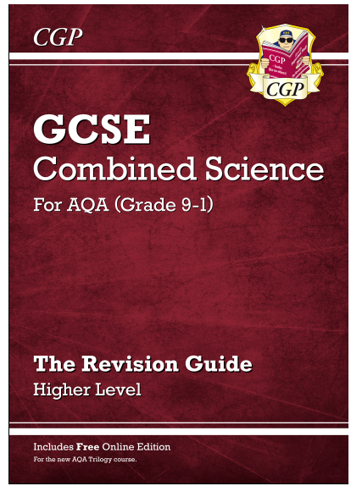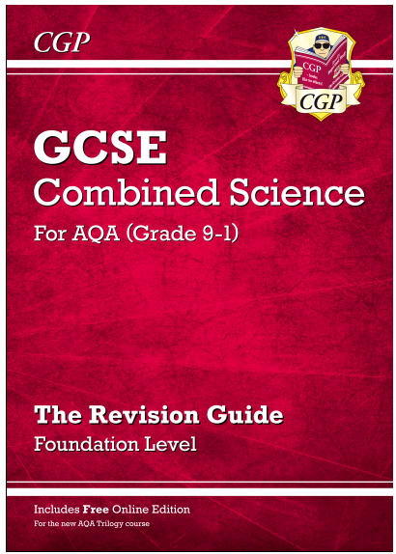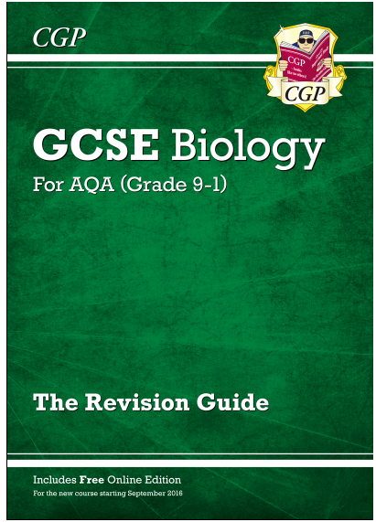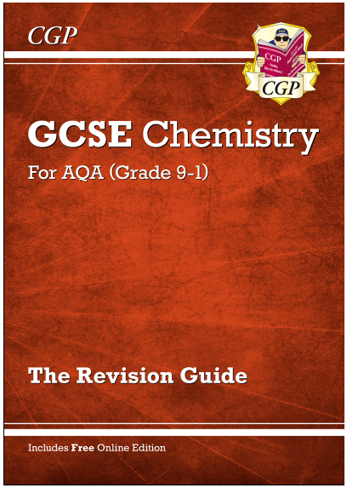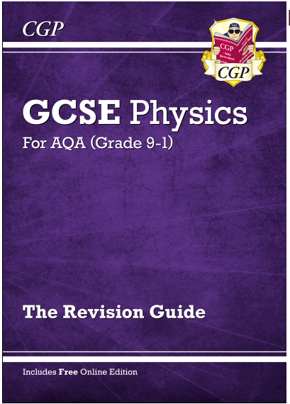
CGP revision guides

Effective Revision
Revising for science examinations can be daunting as there is a huge amount of content to recall and apply. In addition to the guidance you get on general revision, here are the science faculty’s best tips and advice for revising science.
Get active
It is not enough to read notes. Students should make lists of important definitions and learn them. Get others involved! Make flash cards and test yourself regularly. It is amazing how much will be remembered. This is also really important for learning the physics equations.

Past paper questions
The 2018 national cohort were the first group of students to sit the new science specifications. This means there is not a large amount of past paper questions to try. However, the past examination paper questions from previous AQA specifications will still be very useful to revise. The AQA website has pdf files to download. Students should attempt the questions, using their notes, and then check the mark schemes. Mark schemes are very useful documents as students should note the phrases and language that the examiner wants to be used.

Exercise books
Students should use their exercise books – they will have many past paper questions and important notes in these books which will be invaluable.

Show My Homework
Home learning tasks are set weekly on show my homework which involve a variety of different revision strategies including Twenty’s Plenty quizzes. Repetitive quizzing and testing helps students retain small pieces of information.

GCSE bitesize for science
https://www.bbc.co.uk/education/subjects/zrkw2hv is a fantastic resource. It contains most the topics that students need to know in addition to short quizzes and video clips.

YouTube
There are many revision videos on YouTube and many can be an alternative way for students to revise. It is really important that students include GCSE in the search box to ensure the content is relevant.

Seneca Learning
Go to: https://app.senecalearning.com/. Students will have been given a class code by their class teacher, so they can work their way through the assignments set on a regular basis.

The course specification
This document can be found via the AQA website and it is aimed at teachers. However, it does contain statements for all the content that students will be examined on so some students may find it useful as a list to check that they have revised each topic.

List of content to revise
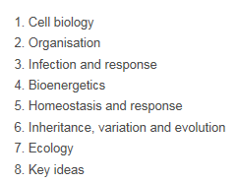
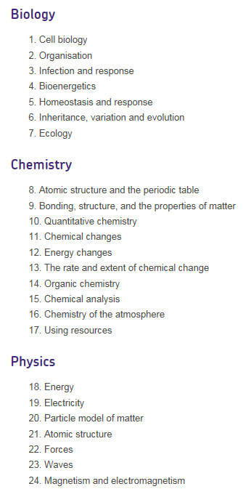
Combined science Separate sciences Biology

Chemistry
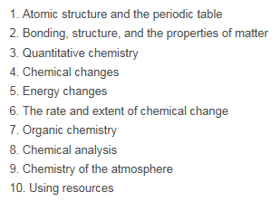

Physics
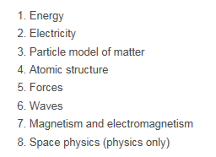

Note: the depth and breadth of content in science is huge. Use a revision guide to check the exact knowledge and understanding required.

