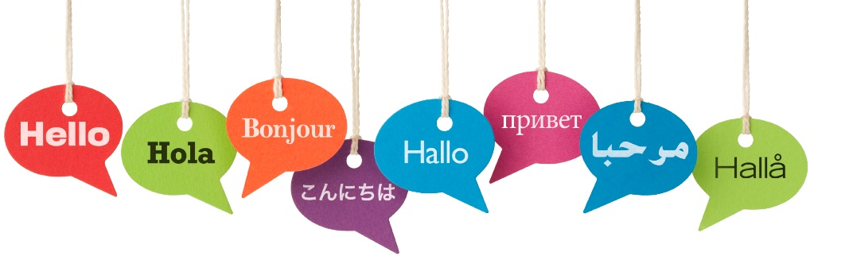
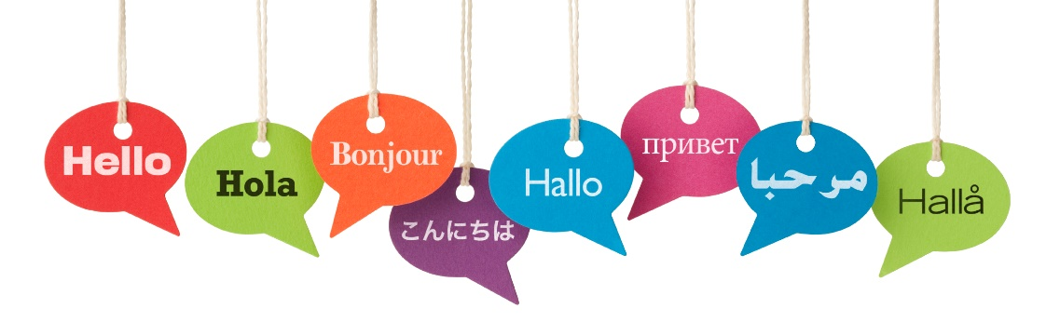
s
GCSE Languages Information

- Exam Papers
- Text Books and Revision Guides
- Course Content
- Grammatical Content
- Revision Tips
- Websites & Apps

Exam Papers: What you have to do…
Exam Board: AQA
Textbooks: ¡Viva! – Spanish
Studio – French

Speaking – 25% (0% in 2021)
- Role Play – roughly 1 minute (15 marks)
  - You will be given a card to look at, which includes a scenario and prompts to help you construct appropriate sentences.
- Photo based discussion – roughly 2 minutes (15 marks)
  - You will be given a photo on any of the topics covered on the course and four bullet points to prepare about it.
- General Conversation – roughly 6 minutes (F), roughly 8 minutes (H) (36 marks)
  - This starts with a pre-prepared presentation of roughly 1 minute.
  - Questions on the same topic as your presentation will follow for a further 3 minutes.
  - Questions on an entirely different topic will then follow for roughly 4 minutes.
PLEASE NOTE: Students taking this qualification in June 2021 will not be sitting a speaking exam.

Writing – 25% (33% in 2021)
Foundation
- Question 1 – Description of a photo
- Question 2 – 50 word piece of writing on any topic
- Question 3 – 90 word piece of writing on any topic
- Question 4 – 5 sentences to translate (Eng – Spa)
Higher
- Question 1 – 90 word piece of writing on any topic
- Question 2 – 150 word piece of writing on any topic
- Question 3 – Passage to translate (Eng – Spa)
Reading – 25% (33% in 2021)
- In this paper you will be reading passages in whichever language you are learning and responding to questions.
- In section A of the paper you will be asked and expected to respond in English.
- In section B of the paper you will be asked and expected to respond in Spanish.
- This paper also includes a small translation from Spanish into English.

Listening – 25% (33% in 2021)
- In this paper you will be listening to audio in whichever language you are learning and responding to questions about what you have heard.
- In section A of the paper you will be asked and expected to respond in English.
- In section B of the paper you will be asked and expected to respond in Spanish.

Revision: What to revise
You are learning a language, which means you need to need to know vocabulary. Use the vocabulary booklet you were given and thoroughly revise it.
You also need to have a good understanding of the grammar of the language you are studying – conjugating verbs, using adjectives, gender, tenses etc.
REMEMBER – you have been learning these things for a long time, and your exercise books are full of useful information. USE THEM.
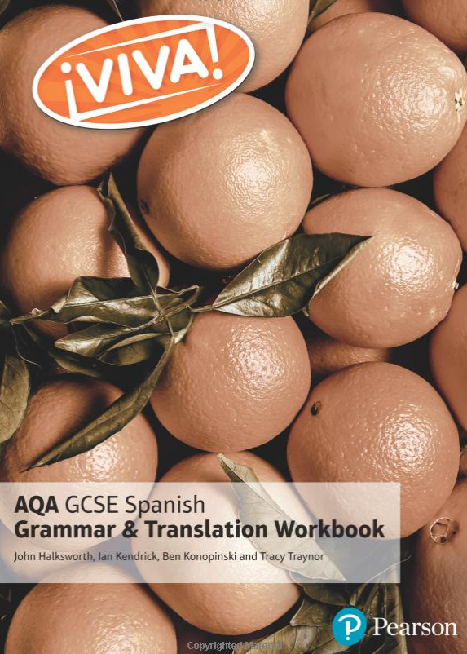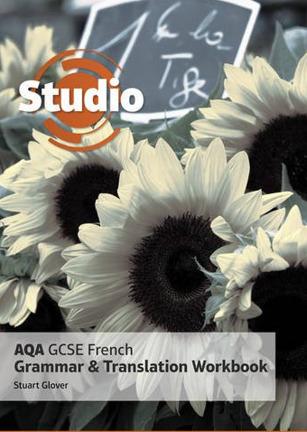
These books are highly recommended.
Remember to buy the AQA versions.

Revision: Course Topics
Any of these topics may be on your exams. You may be expected to write or speak about one of them in detail, so it is important that you familiarise yourself with key vocabulary from each topic. Go through your books thoroughly and look at extended pieces of writing that you have already done for them.

- School
- Free time
- Family, friends and relationships
- Home life
- Local area, travel and tourism
- Holidays
- Future aspirations, study and work
- Global issues

Revision: Grammar
With no support materials to assist you in your exams, it is essential that you have a grasp of how grammar works in the language that you are studying.
The grammar topics below are listed for each language. (H) indicates they are necessary for the higher paper, (F) indicates they are necessary for both foundation and higher papers.
Spanish
- Present tense (F)
- Present continuous tense (F)
- Preterite tense (F)
- Perfect tense (past) (F)
- Imperfect tense (past) (F)
- Imperfect continuous tense (H)
- Pluperfect tense (H)
- Future tense (F)
- Near future tense (F) (voy a + inf)
- Conditional tense (F)
- Present subjunctive (H)
- Imperfect subjunctive (H)
- Passive voice (H)
- Passive with se (H)
- Reflexive verbs (F)
- Modal verbs (F)
- Gender (F)
- Comparatives (F)
- Superlatives (F)
- Prepositions (F)
  - Prepositions
  - Por vs. para
  - Personal a
- Possessive adjectives (F)
- Pronouns (F)
- Possessive pronouns (F)
- Demonstrative pronouns (F)
German
- Present tense (F)
- Perfect tense (past) (F)
- Imperfect tense (past) (F)
- Future tense (F)
- Conditional tense (F)
- The pluperfect tense (H)
- Passive voice (H)
- Infinitive constructions (H)
- Reflexive verbs (F)
- Modal verbs (F)
- Separable verbs (F)
- Imperfect subjunctive (H)
- Cases (F)
  - Nominative
  - Accusative
  - Dative
  - Genitive
- Gender (F)
- Comparatives (F)
- Superlatives (F)
- Word order (F)
  - V2
  - Time, manner, place
  - Coordinating conjunctions
  - Subordinating conjunctions
- Prepositions (F)
- Pronouns (F)

Revision: Tips
The trick when revising a language is to ensure that you actually do something. Only by practising your use of the language will it actively remain in your memory. Try doing the following things:
- Reading comprehension questions
- Practice translations, both sentences and passages
  - Do both Sp/Fr Eng and Eng Sp/Fr
- Write out your verb tables to consolidate the endings
- Test yourself on vocabulary. Look at it, cover it, write it out, check.
- Find a series or film on Netflix / All4 / YouTube etc. that is in Spanish or French. You do not need to understand it in its entirety, but just listening and putting on subtitles helps to get your ear used to hearing the foreign language. The more you expose yourself, the less of a shock you will find listening questions in the exam. There are also Podcasts that you can download and just have on in the background.

Revision: Websites and Apps
There are several website and apps to support you with your revision. Have a look at these.

Websites
- Languages online
- BBC GCSE Bitesize
- Memrise
- OAK ACADEMY KS4 Spanish
  - This website contains videos, tutorials and activities and they are all based on the AQA GCSE specification. They are exceptionally useful.
Apps
- Memrise
- DuoLingo
- Babbel

