OCR A-Level History
History A (OCR H505): Specification

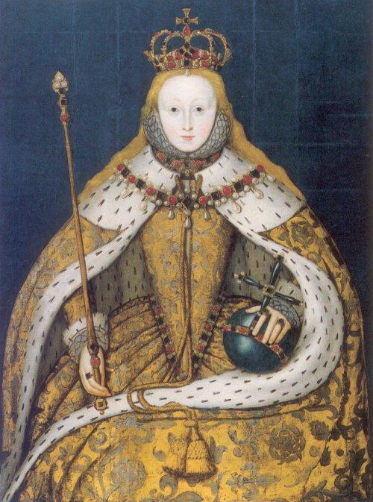
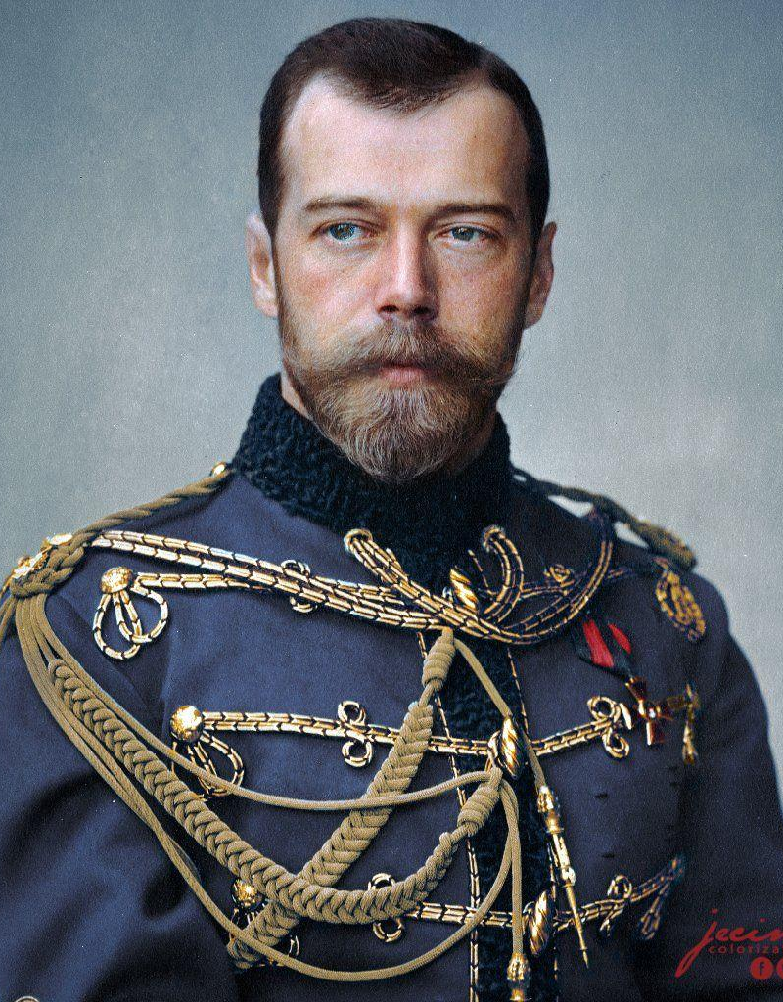
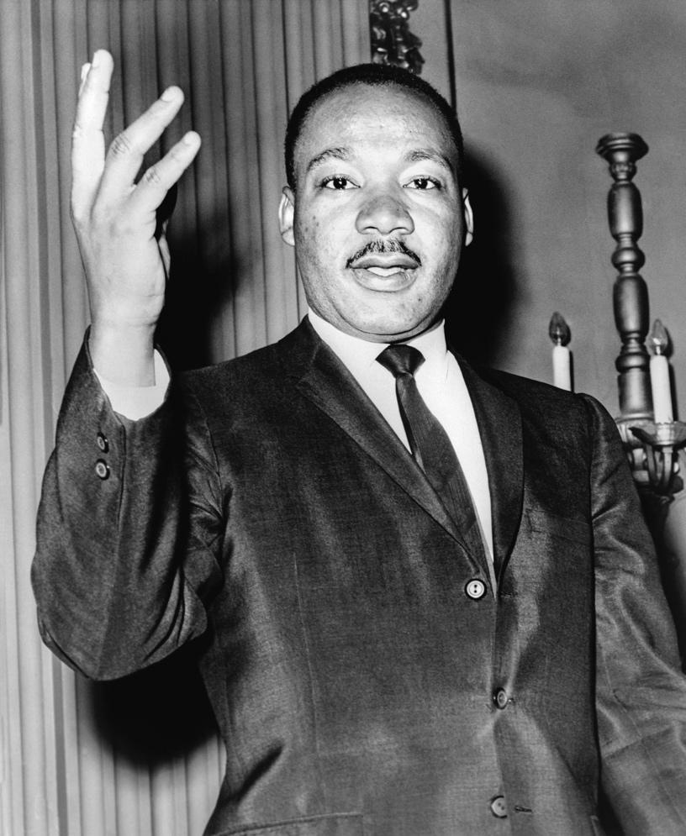
Paper 3 – Civil Rights in the USA 1865-1992
Ref. OCR Y319/01
Paper 1 England 1547-1603: The Later Tudors
Ref. OCR Y107

Paper 2 – Russia, 1894-1941
Ref. OCR Y219 scheme of work

Paper 1: England 1547-1603: The Later Tudors (OCR Y107) | Paper 2: Russia, 1894-1941  (OCR Y219) | Paper 3: Civil Rights in the USA 1865-1992 (OCR Y319/01)
Weighting: 25% of the total A Level  Assessment: 1h30 paper, 50 marks  This paper is assessed in two parts: the enquiry and the period study, and thus the question paper has two sections.  Section A is the enquiry. Learners will answer one compulsory question, requiring them to analyse and evaluate four primary sources in their historical context in order to test a hypothesis. This part of the paper is worth 30 marks.  Section B is the period study. Learners will answer one essay question from a choice of two. This part of the paper is worth 20 marks.  See also:  Historical Association  www.history.org.uk/student/module/8679/a-level-topic-guide-the-tudors  England’s Forgotten Queen (3 episodes, BBC, 2017)  https://www.youtube.com/watch?v=BIPfLeh2bYw | Weighting: 15% of the total A Level  Assessment: 1h paper, 30 marks  Learners will answer one two-part question from a choice of two.  The first part of the question will require learners to compare two factors and to make a judgement about their relative importance. There are 10 marks available.  For the second part of the question learners will write an essay on a different part of the period. As with the British period study essay in unit group 1, this question is worth 20 marks. | Weighting: 40% of the total A Level  Assessment: 2h30 paper, 80 marks  Assessment of units in this unit group is in two parts: the historical interpretations depth study and the thematic essay, and thus the question paper has two parts.  Section A is the interpretations section. Learners will read two extracts from historians about one of the three depth studies specified for their chosen option, and will write an essay explaining which they think is more convincing. This part of the paper is worth 30 marks.  Section B is the themes section. Learners will answer two themes questions from a choice of three, each of which requires an essay covering the whole period studied. This part of the paper is worth 50 marks.  Book 1 Link;  https://www.amazon.co.uk/My-Revision-Notes-level-1865-1992/dp/1471875881/ref=asc_df_1471875881/?tag=bingshoppinga-21&linkCode=df0&hvadid=&hvpos=&hvnetw=o&hvrand=&hvpone=&hvptwo=&hvqmt=e&hvdev=c&hvdvcmdl=&hvlocint=&hvlocphy=&hvtargid=pla-4583451664012698&psc=1  Book 2 Link;  https://www.amazon.co.uk/OCR-Level-History-Rights-1865-1992/dp/0435312669
Topic based essay: Russia, 1894-1941
(OCR Y100)
Weighting: 15% of the total A Level
An extended essay of 3000–4000 words marked out of 40, arising from independent study and research using primary sources and historical interpretations, on a topic of the learner’s choice.
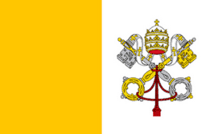
Recommended textbooks and academia

Paper 1: England, 1547-1603 Paper 2: Russia, 1894-1941 Paper 3: America, 1865-1992
