Revision Guidance

CONTENTS PAGE

The course outline | p.2
Exam dates | p.2
Textbooks and revision guides | p.3
Revision apps and websites | p.4-5
Revision Plan (Lessons and independent study) | p.6-13

Course Details.

The biology course you are studying is with AQA and the qualification is made up of three different units.
You will take the full A-level at end of year 13 in the summer of 2021. There will be no option to take any AS exams. The three units you will study are outlined below with further details:
Paper | Topics | Length/ Time | Marks | Worth
Paper 1 | Any content from topics 1– 4, including relevant practical skills | 2 hours | 91 | 35% of your final grade
Paper 2 | Any content from topics 5–8, including relevant practical skills | 2 hours | 91 | 35% of your final grade
Paper 3 | Any content from topics 1–8, including relevant practical skills | 2 hours | 78 | 30% of your final grade

Exam Dates.
Paper | Topics | Length/ Time | Marks | Worth | Exam Date
Paper 1 | Any content from topics 1– 4, including relevant practical skills | 2 hours | 91 | 35% of your final grade | 10 June 2021
Paper 2 | Any content from topics 5–8, including relevant practical skills | 2 hours | 91 | 35% of your final grade | 17 June 2021
Paper 3 | Any content from topics 1–8, including relevant practical skills | 2 hours | 78 | 30% of your final grade | 25 June 2021
Topics
Topics 1-4
Biological molecules
Cell structure and division
Cell membranes
Cells and the immune system
Exchange and transport systems
DNA, RNA and protein synthesis
Diversity and selection
Diversity and classification
Topics 5 –8
Photosynthesis
Energy and ecosystems
Nervous coordination
Homeostasis
Genetics
Populations
Evolution
Gene expression
Gene technology
Textbooks and Revision Guides.
To support your revision you may wish to buy your own you are advised to buy the following textbooks:

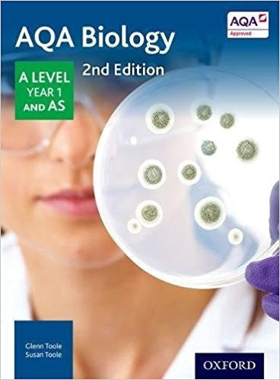
AQA Biology A-level Student Book: Glenn Toole, Susan Toole: Oxford University Press · Paperback · 688 pages · ISBN 0198351771
Available through Amazon

Websites and Additional Reading
If you are a student wishing to expand your biology knowledge further, you need to go beyond your class textbooks. Below is a list of websites and books that may be of interest to you.

Web-sites
www.biozone.co.uk
www.biologymad.com/
www.s-cool.co.uk
www.cellsalive.com
www.whfreeman.com/thelifewirebrodge2/
www.biology.arizona.edu/default.html
www.dnaftb.org/dnaftb/
www.biology.com
www.who.ch
Additional Reading
The Selfish Gene—Richard Dawkins
Double Helix—James Watson
The Blind Watchmaker—Richard Dawkins
The Language of Genes— Steve Jones
New Scientist Magazine
Apps
For organising your revision:
Get Revising | Study Blue | Quizlet
 | 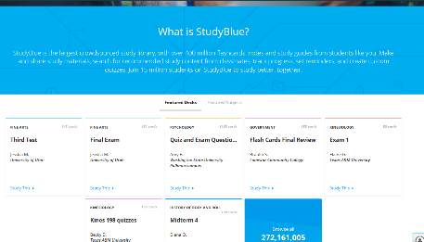 | 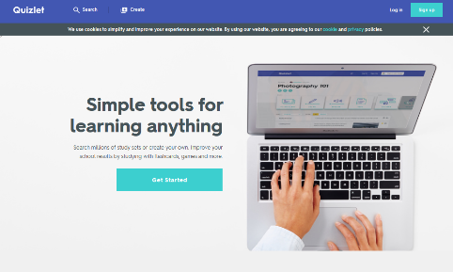
https://getrevising.co.uk/ | https://www.studyblue.com/ | https://quizlet.com/en-gb

Revision App:
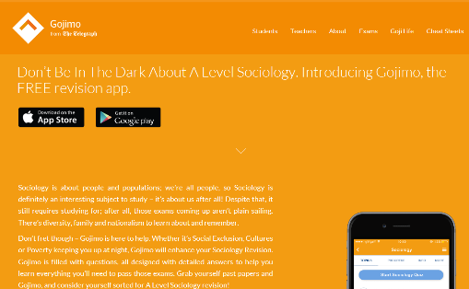
Gojimo is a useful revision app that has been developed by the Telegraph. It has mostly free content but some you do need to pay for.
http://www.gojimo.com/a-level-sociology-revision

