Revision Guidance

CONTENTS PAGE

The course outline | p.2
Exam dates | p.2
Textbooks and revision guides | p.3
Revision apps and websites | p.4 – 5

Course Details.

The chemistry course you are studying is with AQA and the qualification is made up of three different units.
You will take the full A-level at end of year 13 in the summer of 2021. There will be no option to take any AS exams. The three units you will study are outlined below with further details:
Paper | Topics | Length/ Time | Marks | Worth
Paper 1 | Physical and inorganic chemistry, including relevant practical skills | 2 hours | 105 | 35% of your final grade
Paper 2 | Physical and organic chemistry,  including relevant practical skills | 2 hours | 105 | 35% of your final grade
Paper 3 | Any content, including relevant practical skills | 2 hours | 90 | 30% of your final grade

Exam Dates.
Paper | Topics | Length/ Time | Marks | Worth | Exam Date
Paper 1 | Physical and inorganic chemistry, including relevant practical skills | 2 hours | 105 | 35% of your final grade | 07 June 2021 am
Paper 2 | Physical and organic chemistry,  including relevant practical skills | 2 hours | 105 | 35% of your final grade | 14 June 2021 pm
Paper 3 | Any content, including relevant practical skills | 2 hours | 90 | 30% of your final grade | 21 June 2021 am
Topics
Paper 1 Physical and inorganic chemistry topics
Atomic Structure
Amount of Substance
Bonding
Energetics
Chemical Equilibria, Le Chatelier’s Principle and Kc
Oxidation, reduction and redox
Thermodynamics
Equilibrium constant Kp
Electrode potentials and electrochemical cells
Acids and bases
Periodicity
Group 2 the alkaline earth metals
Group 7 the halogens
Properties of period 3 elements and their oxides
Transition metals
Reactions of ions in aqueous solutions
Paper 2 Physical and organic topics
Amount of substance
Bonding
Energetics
Kinetics
Chemical Equilibria, Le Chatelier’s Principle and Kc
Rate equations
Introduction to organic chemistry
Alkanes
Halogenoalkanes
Alkenes
Alcohols
Organic analysis
Optical isomerism
Aldehydes and ketones
Carboxylic acids and derivatives
Aromatic chemistry
Amines
Polymers
Amino acids, proteins and DNA
Organic synthesis
NMR spectroscopy
Chromatography
Textbooks and Revision Guides.
To support your revision you may wish to buy your own you are advised to buy the following textbooks:

AQA Chemistry A-level Student Book: Ted Lister, Janet Renshaw: Oxford University Press · Paperback · 558 pages · ISBN 019835182-5
Available through Amazon
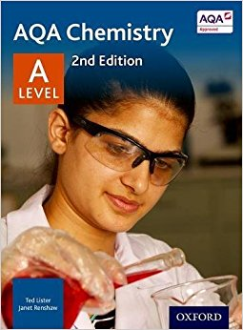

Websites and Additional Reading
If you are a student wishing to expand your chemistry knowledge further, you need to go beyond your class textbooks. Below is a list of websites and books that may be of interest to you.

Web-sites
RSC Chemistry resources for teachers: Learn Chemistry
S-cool, the revision website: A Level Chemistry Revision
Chemguide: Helping you to understand Chemistry
ChemGym: Quizzes for learning and revising A level Chemistry
Twitter: @ChemistryALevel
The Royal Society: Invigorate
TES Connect: Secondary teaching resources
Additional Reading
The Pleasure of Finding Things Out - Richard Feynman
Periodic Tales - Hugh Aldersey-Williams
The Disappearing Spoon - Sam Kean
Uncle Tungsten - Oliver Sachs
The Shocking History of Phosphorus: A Biography of the Devil’s Element - John Emsley
New Scientist Magazine
Apps
For organising your revision:
Get Revising | Study Blue | Quizlet
 | 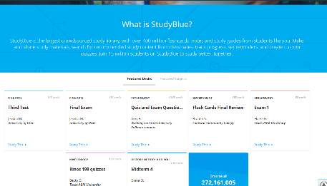 | 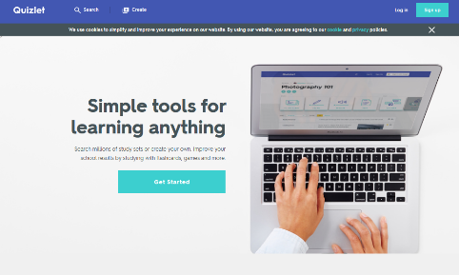
https://getrevising.co.uk/ | https://www.studyblue.com/ | https://quizlet.com/en-gb

Revision App:
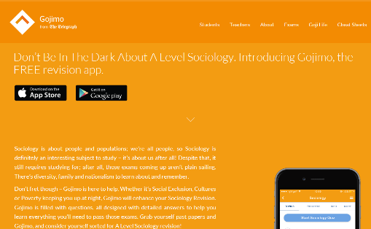
Gojimo is a useful revision app that has been developed by the Telegraph. It has mostly free content but some you do need to pay for.
http://www.gojimo.com/a-level-chemistry-revision

