Revision Guidance

CONTENTS PAGE

The course outline | p.2
Exam dates | p.3
Textbooks and revision guides | p.4
Revision apps and websites | p.4
Exam paper | p.5
What do I need to revise | p.6
KS5 Schedule | p.7

Course Details.

The Drama and Theatre studies course you are studying is with AQA and the qualification is made up of three different units. You will learn through experience, seeing theatre and making theatre for yourselves. You will be introduced to a wide range of theatrical styles and contexts as you explore plays practically, devise and work on performances
You will take the full A-level at end of year 13 in the summer of 2018.

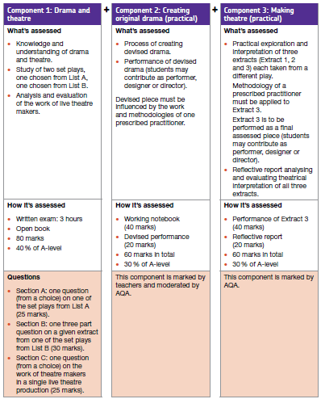

Exam Dates.
Paper Title | Length/ Time | Marks | Worth | Date
Component1 –  Drama and Theatre | 3 hours | 80 | 40% of your final grade | Thursday 10th June pm  3 hours
Component 2  Creating original drama |  | 60 | 35% of your final grade | Practical  16th December 2020
Working notebook
Friday 15th January
Component 3 – Texts in practice |  |  | 35% of your final grade | Practical  24th March 2021
Reflective Log
10th March 2021

Textbooks and Revision Guides.
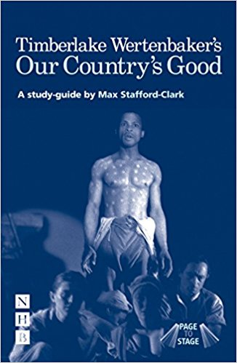
Our Country’s Good Study Guide – Max Stafford Clarke – From page to stage
ISBN: 8601404328534
Benedetti J – The Art of the Actor (Methuen Drama, 2005)
ISBN 9780413773364

Benedetti J – Stanislavski: An Introduction (Methuen Drama, 1982)
ISBN 9780413500304

Elsam P – Acting Characters (Methuen Drama, 2006)
ISBN 9780713675863

Kustow M – Theatre@Risk (Methuen Drama, 2000)
ISBN 9780413738202

Lepage R – Connecting Flights (Methuen Drama, 1997)
ISBN 978 0413 706904

Schumacher C (editor) - Artaud on Theatre (Methuen Drama, 2001)
ISBN 9780413737700

Howl, J – 100 Exercises to get you into Drama School (Methuen
Drama, 2008) ISBN 9781408101322

Kohlhaas, K – The Monologue Audition (Nick Hern Books, 2000)
ISBN 9781854596086

Rodenburg P – The Actor Speaks (Methuen Drama, 1998)
ISBN 9780413700308
Websites.
To support your revision, you may also wish to use revision websites. Below are some suggestions for you.
Spark notes Hedda Gabler: https://www.sparknotes.com/lit/heddagabler/
www.edexcel.com/gcedrama www.imagi-nation.com/moonstruck http://hellenicbookservice.com/
www.nationaltheatre.org.uk www.rsc.org.uk www.stagework.org.uk

Component 1 – Written paper
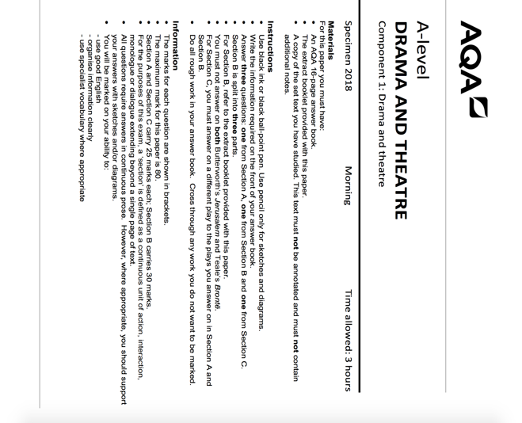
Answer only 1 question
Spend 50 minutes answering
Read the question carefully
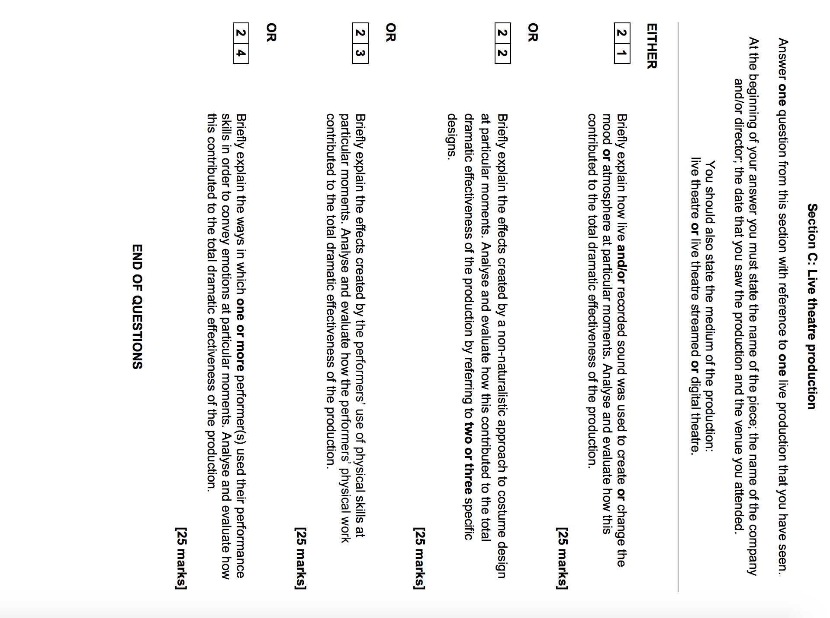
- Use black ink or black ball-point pen.
- Use pencil only for sketches and diagrams.
- Write the information required on the front of your answer book.
- Answer three questions: one from Section A, one from Section B and one from Section C.
- Section B is split into three parts.
- For Section B, refer to the extract booklet provided with this paper.
- For Section C, you must answer on a different play to the plays you answer on in Section A and Section B.
- Do all rough work in your answer book.
SECTION A – Hedda Gabler  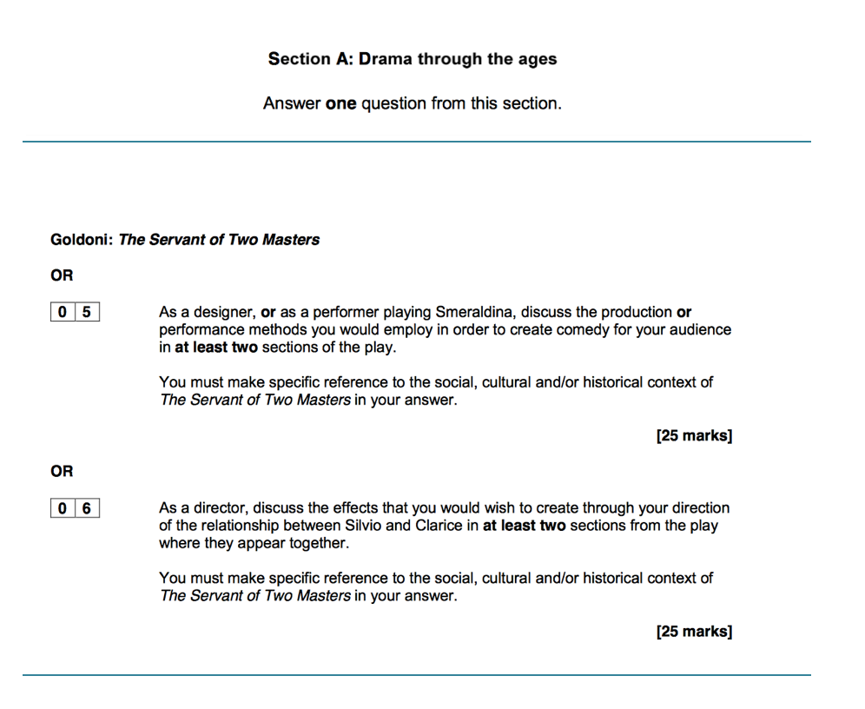 | SECTION B – Our Country’s Good  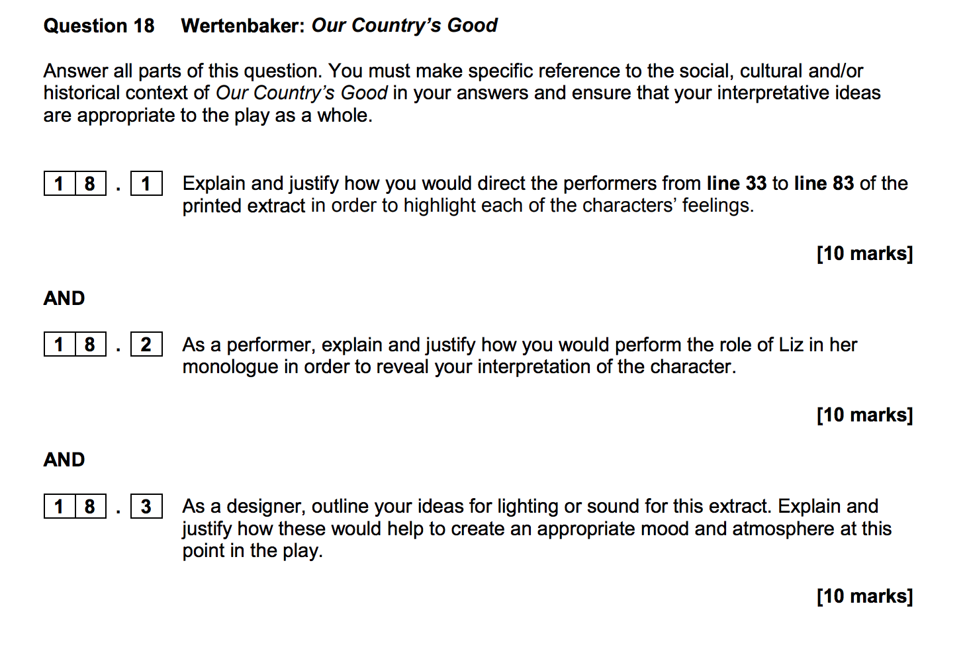
Answer only 1 of the two questions  Spend 5 minutes reading  Spend 45 minutes answering  SECTION C – Live Theatre | Answer all 3 questions  Read extract carefully – 5 minutes  Question 1 – 25 mins  Question 2 – 25 min  Question 3 – 25 mins
What do I need to revise for component 1?
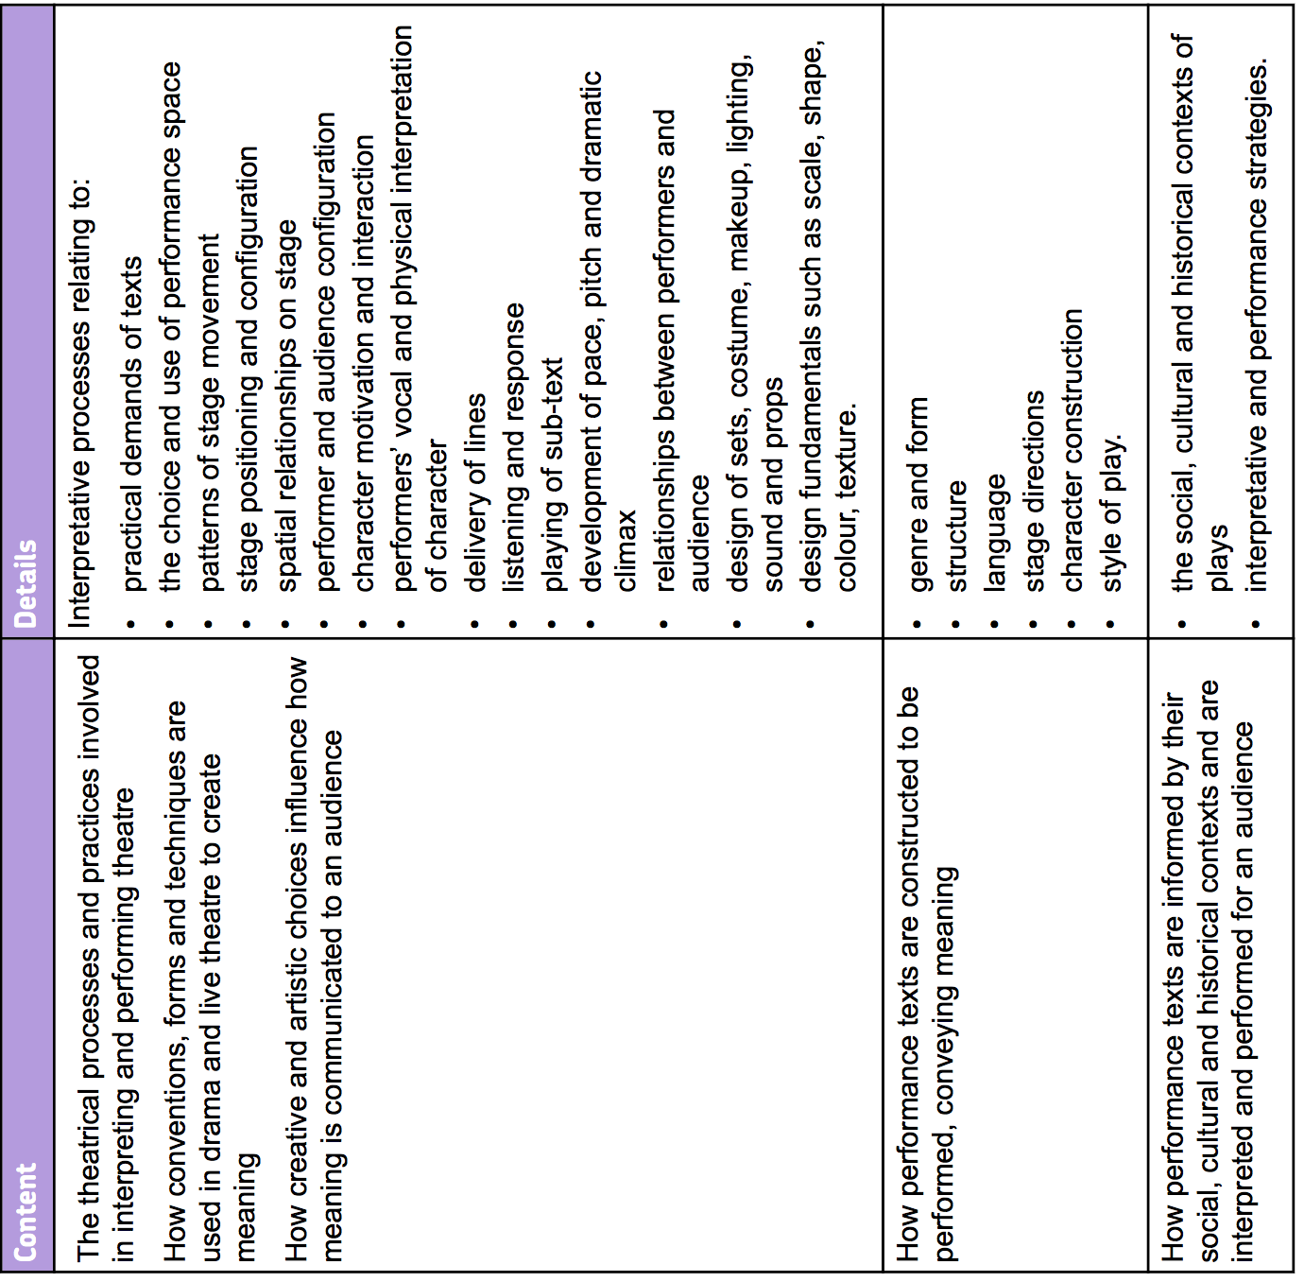
SECTION A | SECTION B | SECTION C
A Servant for Two Masters – Carlo Goldini  - Characters  - Relationships  - Historical and social context  - Costume  - Carlo Goldini  - Style and genre | Our Country’s Good – Timberlake Wertenbaker  - Characters  - Design  - Costume/props  - Lighting/SFX  - Historical and social context  - Style and genre | Live Theatre  - The perceived aims and success of the production team.  - Research the chosen play  - Collaboration of performers and directors and designers  - Audience experience and response

KS5 Schedule for Drama Yr.13
SCHEDULE: Y13 Drama
Week beg | Teaching Focus / Assessment
Sept 7 | C2 Devising C1 OCG
Sept 14 | C2 Devising C1 OCG
Sept 21 | C2 Devising C1 OCG
Sept 28 | C2 Devising C1 OCG
Oct 5 | C2 Devising C1 OCG
Oct 12 | C2 Devising C1 OCG Assessment OCG questions
Oct 19 | C2 Devising C1 OCG
Oct 26 | HALF TERM REVISE HEDDA GABLER
Nov 2 | C2 Devising C1 OCG
Nov 9 | C2 Devisig C1 OCG
Nov 16 | C2 Devising C2 Working Notebook
Nov 23 | C2 Devising C1 OCG
Nov 30 | C2 Devising C2 Working Notebook
Dec 7 | C2 Devising C1 OCG - Design question
Dec 14 | C1 Live theatre C1 Hedda Gabler
Dec 21 | XMAS REVISE OUR COUNTRY’S GOOD
Dec 28 | XMAS REVISE HEDDA GABLER
Jan 4 | C1 Live Theatre C1 Hedda Gabler exam prep
Jan 11 | C3 Live Theatre exam prep C1 OCG exam prep
Jan 18 | Mock Prep Mock examination – Full paper
Jan 25 | C3 Making Theatre WORKING NOTEBOOK DEADLINE
Feb 1 | C3 Making Theatre C1 Hedda Gabler
Feb 8 | C3 Making Theatre C3 Reflective report
Feb 15 | HALF TERM Revise Hedda Gabler and OCG
Feb 22 | C3 Making Theatre
March 1 | C3 Making Theatre DEADLINE REFLECTIVE REPORT
March 8 | C3 Making theatre
March 15 | C3 Making Theatre
March 22 | MAKING THEATRE LIVE PERFORMANCE - EXAM
March 31 | Revise core texts
April 5 | Revise core texts
April 19 | C1 OCG
April 26 | OCG Live Theatre
May 3 | OGC Hedda Gabler
May 10 | OGC LIVE THEATRE
May 17 | OGC Hedda Gabler
May 24 | OCG Hedda Gabler LIVE THEATRE
May 31 | HALF TERM – Revise core texts
June 7 | OCG Hedda Gabler LIVE THEATRE
June 10 | C1 WRITTEN EXAM – Our Country’s Good – Live Theatre – Hedda Gabler

