Revision Guidance

CONTENTS PAGE

The course | p.2
Exam dates | p.2
Textbooks and revision guides | p.3
Revision apps and websites | p.4
Keep Calm and carry on….. (guidance about managing revision) | p.5
How to structure revision | p.6
Exam paper for Unit 1 | p.7
What do I need to revise for Unit 1? | p.8
Exam paper for Unit 2 | p.9
What do I need to revise for Unit 2? | p.10
Exam paper for Unit 3 | p.11
What do I need to revise for Unit 3? | p.12

Course Details.

The sociology course you are studying is with OCR and the qualification is made up of three different units. These units cover the main sociological themes of socialisation, culture, identity, power, control and inequality. Research methods will also be assessed as it is a foundation within the subject.

You will take the full A-level at end of year 13 in the summer of 2018. There will be no option to take any AS exams. The three units you will study are outlined below with further details:
Paper Title | Topics | Length/ Time | Marks | Worth
Unit 1 – Education with Theory and Methods | Section A: Education and Methods in Context  Section B: Theory and Methods | 2 Hours | 80 | 33% of your final grade
Unit 2– Topics in Sociology | Section A: Families and Relationships  Section B: Beliefs in Society | 2 Hours | 80 | 33% of your final grade
Unit 3 – Crime and Deviance with Theory and Methods | Section A: Globalisation and the digital social world  Section B: Research Methods in Context | 2 Hours | 80 | 33% of your final grade

Exam Dates.
Paper Title | Length/ Time | Marks | Worth | Date
Unit 1 – Education with Theory and Methods | 2 Hours | 80 | 33% of your final grade | 7th June 2021 am
Unit 2– Topics in Sociology | 2 Hours | 80 | 33% of your final grade | 12th June 2021 pm
Unit 3 – Crime and Deviance with Theory and Methods | 2 Hours | 80 | 33% of your final grade | 21st June 2021 am
Textbooks and Revision Guides.
To support your revision you may wish to buy your own textbook and you are advised to buy the following ones:

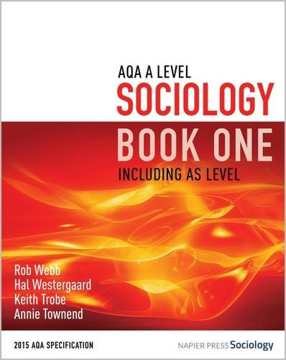
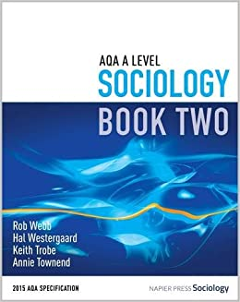
- AQA Sociology for A-Level Book 1
- AQA Sociology for A-Level Book 2
- Available through Amazon
- Each textbook costs around brand new £25. You may get a cheaper copy through Amazon if you buy a used copy

If you don’t wish to purchase a textbook, there are a number of textbooks in the academy for you to use. If you wish to use any of the books during an independent study periods or for a day then you must ask permission from one of the sociology teachers.

Other resources will be available to you throughout the course such as sociology articles and educational documentaries. We suggest though that you buy the OCR Student Study Guide to support your revision. You may wish to purchase these instead of a textbook. They are available through Amazon and cost around £9.99. The titles of the guides you need are:

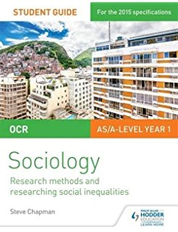
- OCR Sociology Student Guide 1: Socialisation, Culture and Identity with Family (OCR AS/A Level)

- OCR Sociology Student Guide 2: Researching and understanding social inequalities (OCR AS/A Level)

- OCR Sociology Student Guide 4: Debates: Globalisation and the digital social world; Education (OCR A Level Year 2)

If you are a student wishing to expand your Sociological knowledge further, keeping up to date with current events is important. To do this you need to go beyond your class textbooks. Below is a list of programmes that may be of interest to you.
- The news
- Panorama (BBC 1)
- Tonight (ITV3)
- Dispatches (Channel 4)
- Question Time (BBC 1)
Apps and Websites.
To support your revision you may also wish to use revision websites and/or apps. Below are some suggests for you.

For revision content:
Study Wise | S-Cool | Revise Sociology
 | 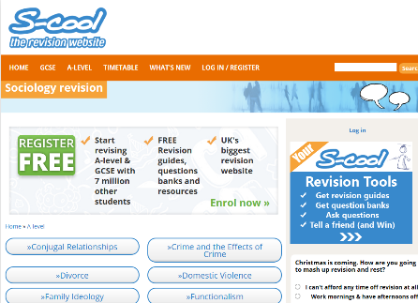 | 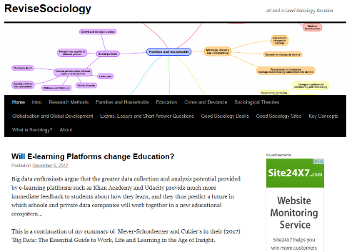
https://studywise.co.uk/a-level-revision/sociology/ | https://www.s-cool.co.uk/a-level/sociology | https://revisesociology.com/

For organising your revision:
Get Revising | Study Blue | Quizlet
 | 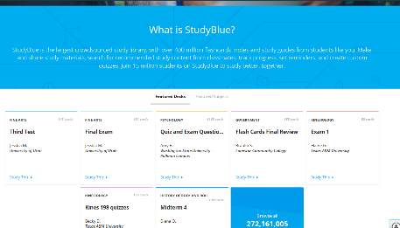
https://getrevising.co.uk/ | https://www.studyblue.com/ | https://quizlet.com/en-gb

Revision App:
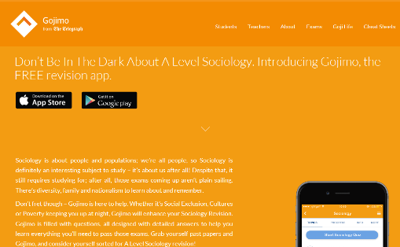
Gojimo is a useful revision app that has been developed by the Telegraph. It has mostly free content but some you do need to pay for.
http://www.gojimo.com/a-level-sociology-revision

Keep Calm and Carry On….

Exams can be very stressful and can cause people anxiety so it is really important to look after yourself during this time. Due to this people can become unfocused. Being organised is one of the best ways of managing this but it isn’t the only strategy you can use. Follow the advice below to help yourself manage your revision without becoming too overwhelmed.

- Keeping up Motivation:
It is really important that you maintain motivation between now and the exams. Some people do find this really challenging but you can use different techniques to help you with this. For example plan in rewards to yourself when you achieve particular targets such “I won’t watch my favourite program until I can remember what the function of protein is”. You could always begin with a topic you find really interesting to get you started and make sure you have a routine. This will keep you focused more.

- Concentration:
Most students say that concentration is an issue. We often find it difficult to concentrate because we either get bored, anxious about things or we day-dream. What we need to do is remove these issues but this can be difficult. Having planned revision and revising in blocks will help you but you also need be very strict with yourself about maintaining your concentration.

- Organising your Space:
It is really important that you have a place where you can revise in peace. Spending time organising this space so that it free from distractions and has all the resources you need is very important. Make sure that you don’t have your mobile phone near you or other distractions such as laptops and tablets. Having a designated work place will also help you mentally as you will get into the mindset that this is where you work. It is really advisable that you don’t work on your bed as well as this can give you conflicting messages as your bed is usually somewhere you relax.

- Sleep:
This then brings us to sleep. It is really important that you are getting enough sleep whilst you are revising so don’t start staying up all night trying to revise! It is important to have a regular bed time as this will also help you get up in the morning to carry on revision. Also making sure you “switch off” before going to bed can help you to sleep better. For example, don’t revise right up to going to bed. Stop at least one hour before. In this time do something you find relaxing. This might be having a bath or doing exercise (something else that helps with revision). Whatever it is make sure you also give yourself some me time.

Remember though revision is key to success in the summer make sure you are not over doing it as this too will impact on the success of your revision.

For further information about coping with exams please see - http://www.ucl.ac.uk/support-pages/information/coping-with-exams - which was used to complete this page.
How to Structure Revision

Revise in 3 blocks of 20 – 30 minutes when you go over your revision tools. There are many ways in which to do this now. Below are some examples.

Example One:  Block 1 – Revise one aspect of a topic  BREAK  Block 2 – Plan answer to an exam question on that topic  BREAK  Block 3 – Write answer in timed conditions | Example Two:  Block 1 – Revise one aspect of a topic  BREAK  Block 2 – Re-create a revision tool for that aspect of the topic  BREAK  Block 3 – Compare the resources, what did you miss? Add this onto your new resource in a different colour.

During the school holidays and the run up to your actual exams only revise for two sessions a day so you don’t over load yourself. For example this means you may revise like this:
 | MORNING SESSION | AFTERNOON SESSION | EVENING SESSION
Monday | Sociology:  9am to 10:30am – 3 blocks of 20 mins with 10 mins breaks  11am to 12:30pm – 3 blocks of 20 mins with 10 mins breaks | Another Subject:  1:30pm to 3pm – 3 blocks of 20 mins with 10 mins breaks  3:30pm to 5pm – 3 blocks of 20 mins with 10 mins break | No revision
Tuesday | Another Subject:  9am to 10:30am – 3 blocks of 20 mins with 10 mins breaks  11am to 12:30pm – 3 blocks of 20 mins with 10 mins breaks | No revision | Sociology:  4:30 pm to 5pm - 3 blocks of 20 mins with 10 mins breaks  5:30pm to 7pm - 3 blocks of 20 mins with 10 mins breaks

Note: Also make sure that you’re not revising every day
Exam Paper for Unit 1 – Education and Methods in Context

- You must use black ink

- You must answer all the questions in Section A

- You must answer the questions for Families and Relationships for Section B

- Clearly show the number of the question you are answering

- Don’t doodle on your script

In the first 5 minutes…………
- Read the source materials for Section A

- Read all the questions

- Mini-plan for each question – e.g. write down studies you might use, theories you might refer to and key concepts

- If this will panic you split it in half – 2.5 minutes for Section A and then 2.5 minutes for Section B

SECTION A | SECTION B
TIMINGS:  5 mins - Question 1  10 mins – Question 2  20 mins – Question 3  40 mins – Question 4  Total for Section: 1 hour 15 mins | TIMINGS:  30 mins – Question 5  15 mins – Question 6  Total for Section: 45 mins
What do I need to revise for Unit 1?
SECTION A | SECTION B
What is the role of education in society?  - Theoretical views of the role of education:  - functionalism  - Marxism  - liberal  - New Right  - Social Democratic  - feminism  - Theoretical explanations of the relationship between education and work:  - functionalism  - Marxism  - New Right  Educational inequalities in a global context:  - the global ‘gender apartheid’ and disparity  - Roles and processes in schools  - Student subcultures  How can differential educational achievement be explained?  Explanations for differential educational achievement:  - inside and outside school factors  - structural, material and cultural factors  - theoretical approaches  - functionalism  - Marxism  - interactionism  - social democratic  - feminism  - New Right  How has the UK education system changed?  - The diversity of educational provision  - Government policies from 1988 onwards, including vocational and work-based training  - Ideological influences on government educational policy  - The impact of educational policies on:  - competition, diversity and choice  - raising standards  - equality and equality of opportunity  - globalisation and education | Research Methods  Research Design and Considerations  - Practical Issues  - Ethical Issues  - Theoretical and Methodological considerations  - Positivism  - Interpretivism  - Quantitative and qualitative methods of research  - Primary and Secondary data  - The key research concepts:  - validity  - reliability  - representativeness  - generalisability  - Objectivity and Subjectivity  - Value Freedom  - Sampling processes and techniques (random, systematic, stratified, snowball, volunteer, opportunity, purposive and quota)  - Access and gatekeeping  Sources of Data  - Questionnaires  - Interviews  - Observations  - Experiments  - Secondary Sources of data  - Official Statistics  - Documents  - Mixed methods  Sociological Theory  Perspectives in Sociology (Outlines and Evaluations)  - Functionalism  - Marxism and Neo-Marxism  - Feminism  - Social Action Theories  - Modernity and Post Modernity  Debates in Sociology  - Sociology as a Science  - Value Freedom  - Positivism versus Interpretivism  - Sociology and Social Policy

Exam Paper for Unit 2– Topics in Sociology
- You must use black ink

- You must answer all the questions in Section A and B

- Clearly show the number of the question you are answering

- Don’t doodle on your script

SECTION A (Families and Households) | SECTION B (Beliefs in Society)
TIMINGS:  15 mins – Question 1  15 mins – Question 2  30 mins – Question 3  Total for Section: 60 mins | TIMINGS:  15 mins – Question 1  15 mins – Question 2  30 mins – Question 3  Total for Section: 60 mins

What do I need to revise for Unit 2?
SECTION A (Families and Households) | SECTION B (Beliefs in Society)
The diversity of family and household types in the contemporary UK:  - nuclear families  - extended families  - lone parent families  - reconstituted families  - same-sex families  - non-family households  Changing patterns of marriage, cohabitation, separation, divorce, childbearing and the life course  Aspects of and reasons for family and household diversity in the contemporary UK, including:  - demographic trends in the United Kingdom since 1900: birth rates, death rates, family size, life expectancy, ageing population, and migration and globalisation  - the nature of childhood, and changes in the status of children in the family and society  The ideology of the nuclear family and the theoretical debates about the role and desirability of the nuclear family in contemporary society:  - functionalism  - New Right  - Marxism  - feminism  - postmodernism  Roles and relationships between partners and how they are changing, including issues of power.  Gender roles, domestic labour and power relationships within the family in contemporary society.  Roles and relationships between parents and children and how they are changing, including issues of power.  The economy and to state policies and how they have affected the family. | What is Religion?  Different definitions of Religion:  - Substantive definitions  - Functional definitions  - Social Constructionist definitions  The diversity of religions and beliefs:  - New Religious Movements (NRM)  - Appeal of NRMs and NAMs  - Sects and Cults  - Growth of the New Age  Theories of religion and Religion and Social change  - Social Conservatism and Functionalism  - Social Conservatism and Marxism  - Social Conservatism and Feminism  - Social Change and Weber  - Social Change and Contemporary examples  Religion and Social Groups  - Ethnicity and Religion  - Gender and Religion  - Age and Religion  Religion and Secularisation  The ideas around secularisation and why it is occurring and where it is occurring:  - Evidence and arguments supporting Secularisation  - Evidence and arguments against Secularisation  - Evaluation of the secularisation debate  Religion and Globalisation  - Religion and Economic development  - Religious Fundamentalism  - Religion as cultural defence  Religion, Ideology and Science  - Science as a belief system  - Ideologies as belief systems  - Marxism and Ideology  - Feminism and Ideology

Exam Paper for Unit 3 – Crime and Deviance with Theory and Methods
- You must use black ink

- You must answer all the questions in Section A

- You must answer the questions for Education for Section B

- Clearly show the number of the question you are answering

- Don’t doodle on your script

SECTION A | SECTION B
TIMINGS:  5 mins - Question 1  10 mins – Question 2  20 mins – Question 3  40 mins – Question 4  Total for Section: 1 hour 15 mins | TIMINGS:  15 mins – Question 5  30 mins – Question 6  Total for Section: 45 mins

What do I need to revise for Unit 3?
SECTION A (Crime and Deviance) | SECTION B (Theory and Methods)
Introduction to crime and Deviance:  - Why do people commit crime?  - Definitions of:  - crime, deviance, social order and social control  Theories of Crime and Deviance  - Functionalism and Crime  - Marxism and crime  - Interactionism and Crime  - Realism and Crime  - Feminism and Crime  - Locality Theory  - Postmodernism and Crime  Social distribution of Crime  - Trends in crime:  - Official Crime Statistics (OCS)  - Crime Survey of England and Wales (CSEW)  - Gender and Crime  - Class and Crime  - Ethnicity and Crime  Globalisation and Crime  - How has globalisation impacted organised crime?  - Corporate and Occupational crime  - State crime  - Green Crime  - Cyber Crime  - Media and Crime  - Media as a cause of crime  - Media as a cause of fear  Crime control and prevention  - Realism and crime control  - Surveillance  - The criminal justice system  - Punishments  - Victimology | Research Methods  Research Design and Considerations  - Practical Issues  - Ethical Issues  - Theoretical and Methodological considerations  - Positivism  - Interpretivism  - Quantitative and qualitative methods of research  - Primary and Secondary data  - The key research concepts:  - validity  - reliability  - representativeness  - generalisability  - Objectivity and Subjectivity  - Value Freedom  - Sampling processes and techniques (random, systematic, stratified, snowball, volunteer, opportunity, purposive and quota)  - Access and gatekeeping  Sources of Data  - Questionnaires  - Interviews  - Observations  - Experiments  - Secondary Sources of data  - Official Statistics  - Documents  - Mixed methods  Sociological Theory  Perspectives in Sociology (Outlines and Evaluations)  - Functionalism  - Marxism and Neo-Marxism  - Feminism  - Social Action Theories  - Modernity and Post Modernity  Debates in Sociology  - Sociology as a Science  - Value Freedom  - Positivism versus Interpretivism  - Sociology and Social Policy

