Revision Guidance
Mathematics

CONTENTS PAGE

The course outline | p.2
Exam dates | p.3
Revision apps and websites | p.4
What do I need to revise for Pure? | p.5
What do I need to revise for Statistics? | p.11
What do I need to revise for Mechanics? | p.13
Support available in school | p.15

Course Details.
The mathematics course that you are studying is with Edexcel and the qualification is a two year course split into three area of mathematics: Pure, Mechanics and Statistics (outlined below).
Full details of the course including module details can be found here:
https://qualifications.pearson.com/content/dam/pdf/A%20Level/Mathematics/2017/specification-and-sample-assesment/a-level-l3-mathematics-specification-issue4.pdf

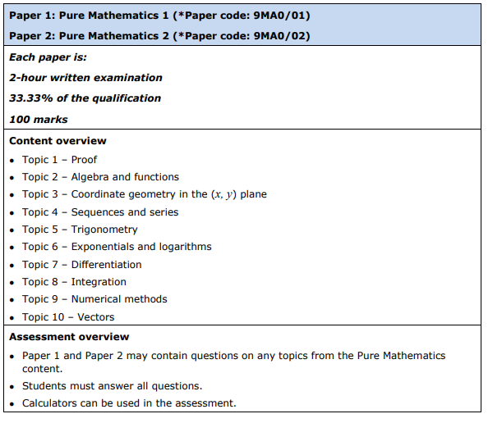

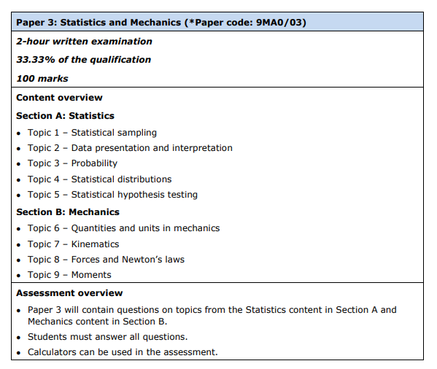

Exam Dates.

Apps and Websites.
To support your revision you may also wish to use revision websites and/or apps. Below are some suggests for you.
For revision content:
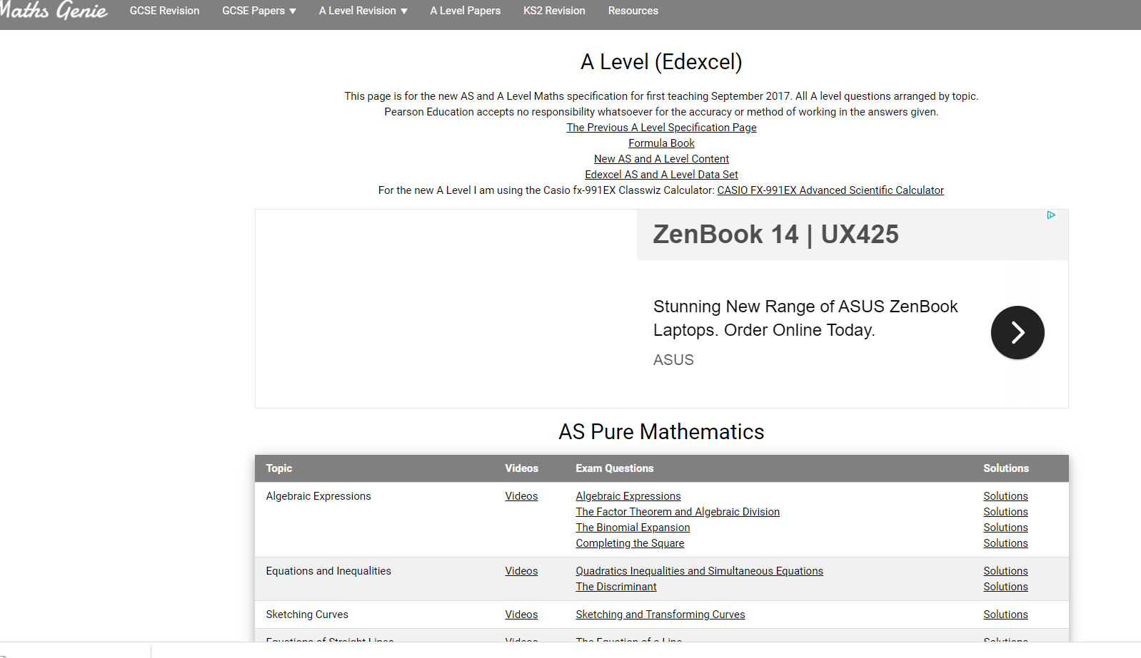  Mathsgenie  (For topic exam questions (y12/13), videos, solutions and extra exam questions from the C1,C2,C3,C4 modules) | 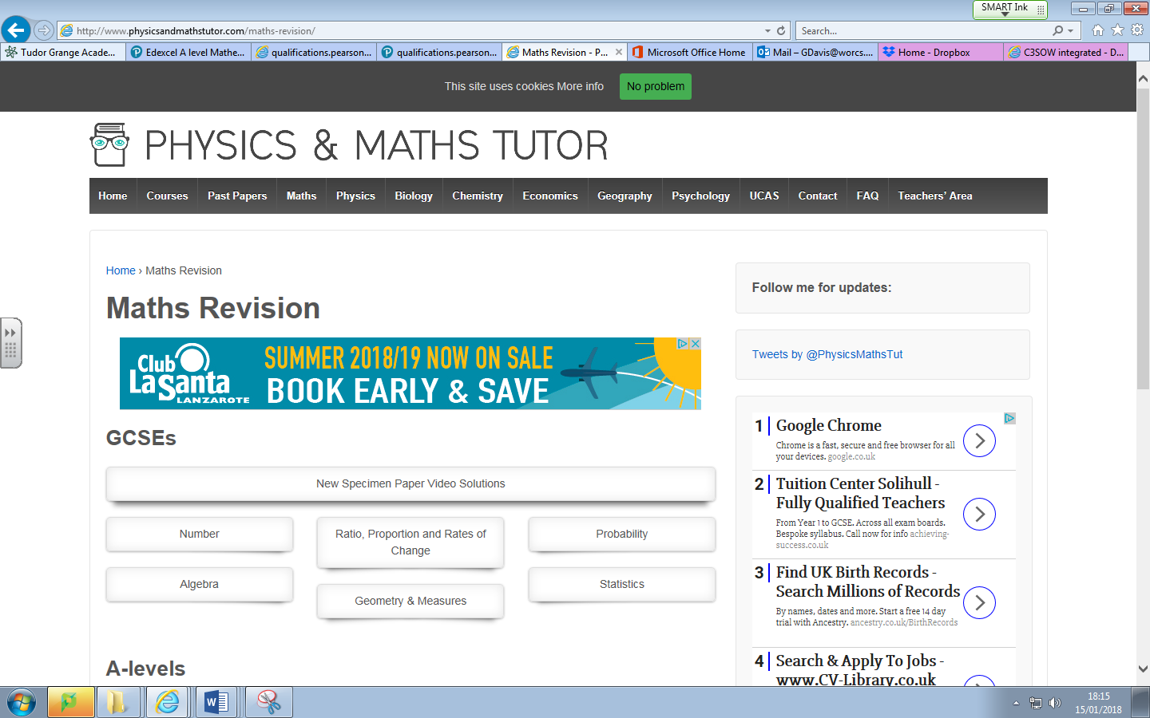  http://www.physicsandmathstutor.  com/maths-revision/  (Revision notes, summary sheets, topic question packs & past papers)
Mathed up
Extra revision videos and exam question
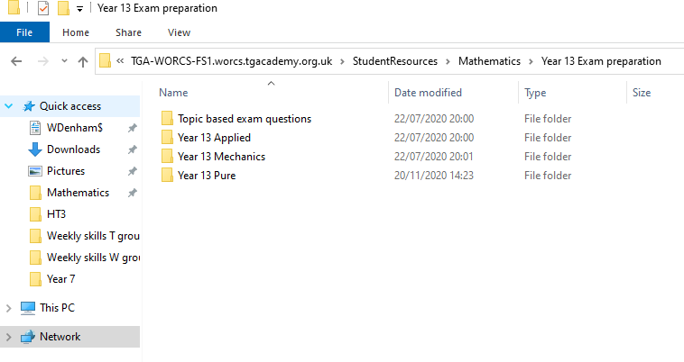
Student drive:
Exam past papers, topic papers and some more revision guidance.

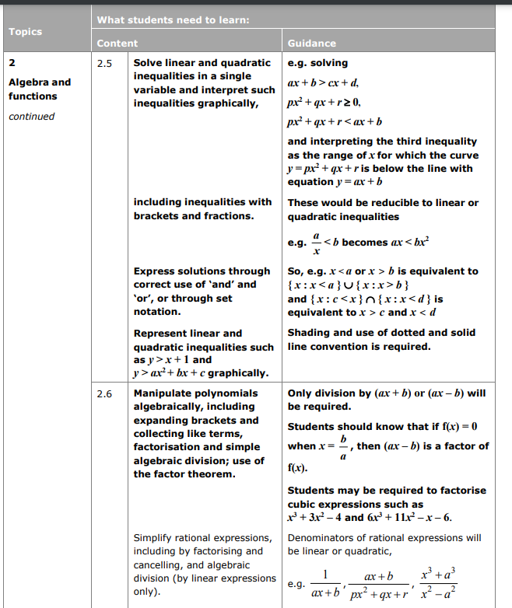
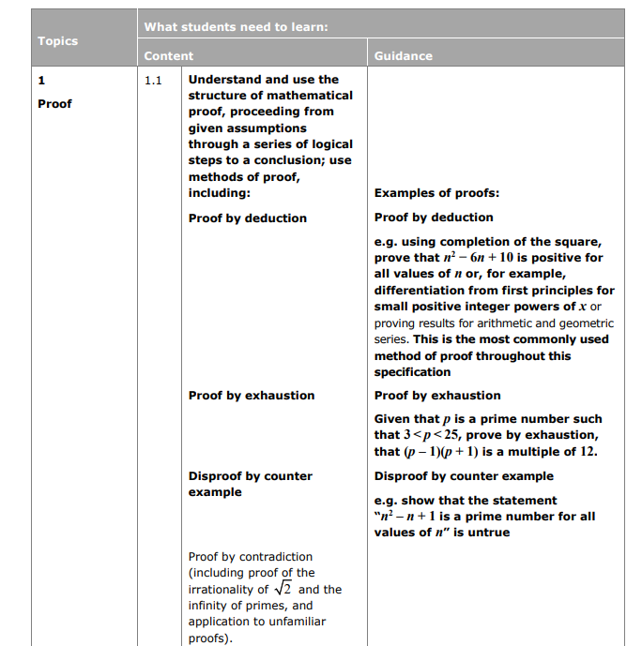
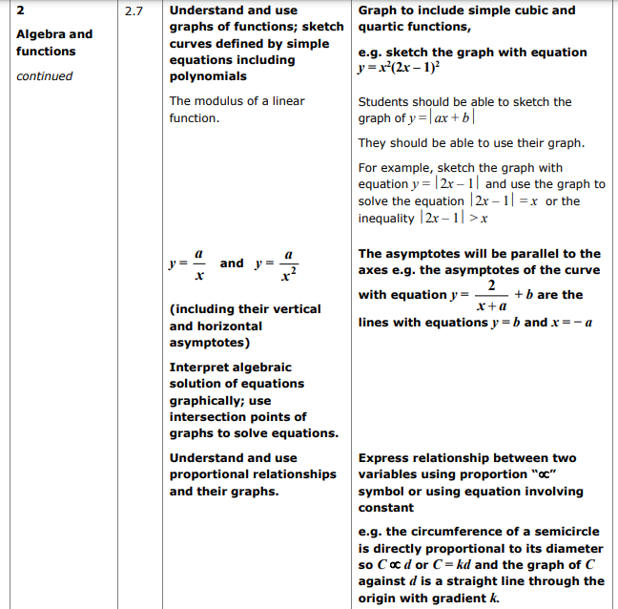
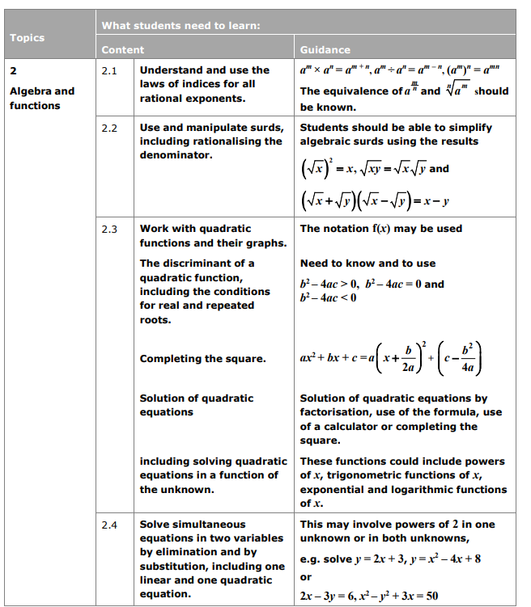
What do I need to revise for Pure?

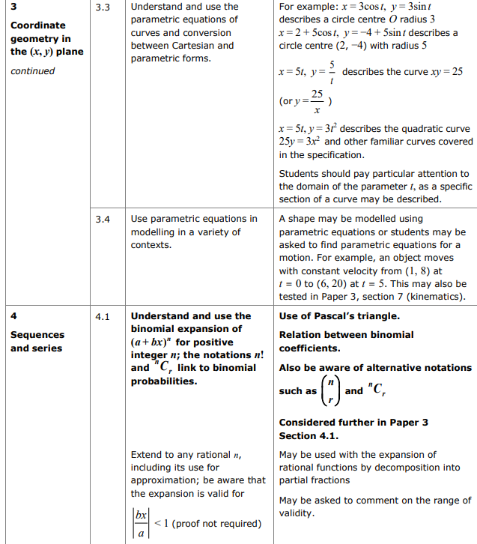
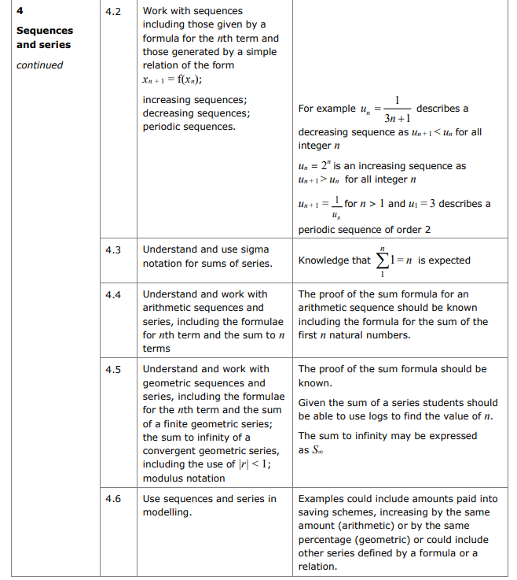
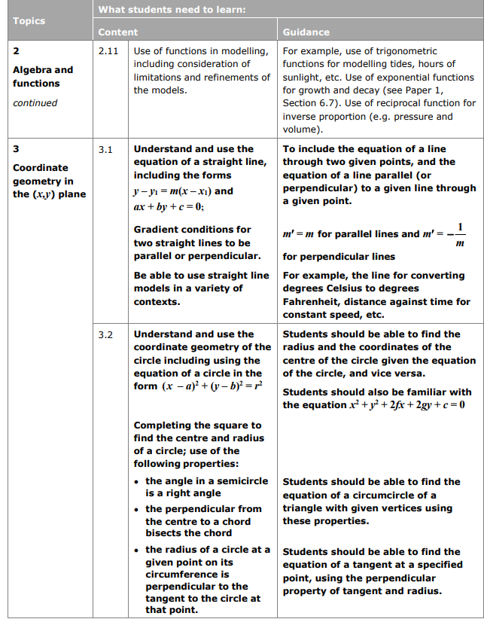
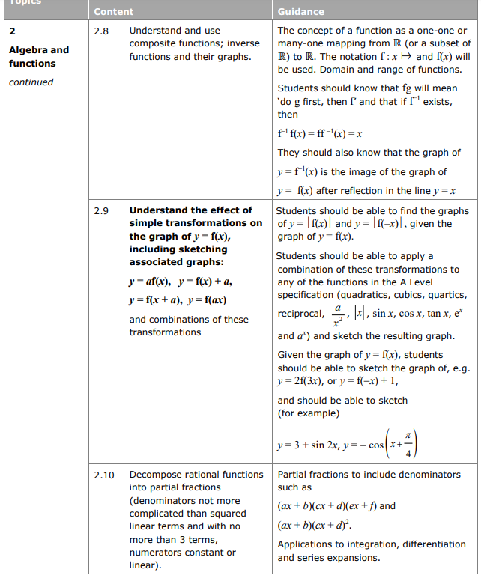
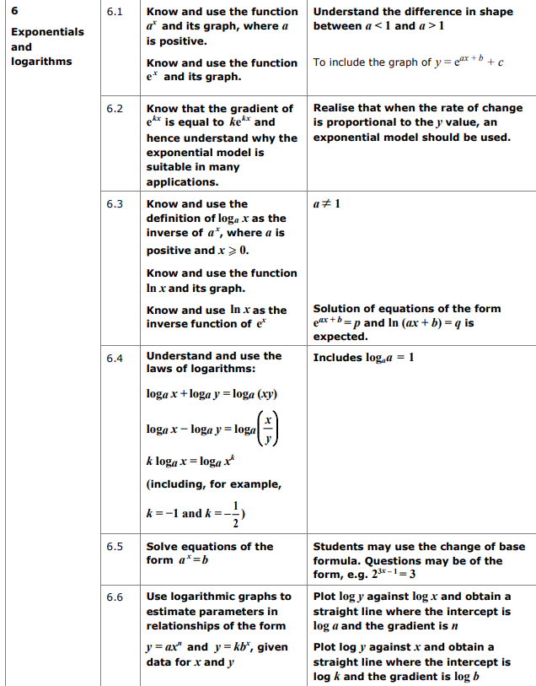
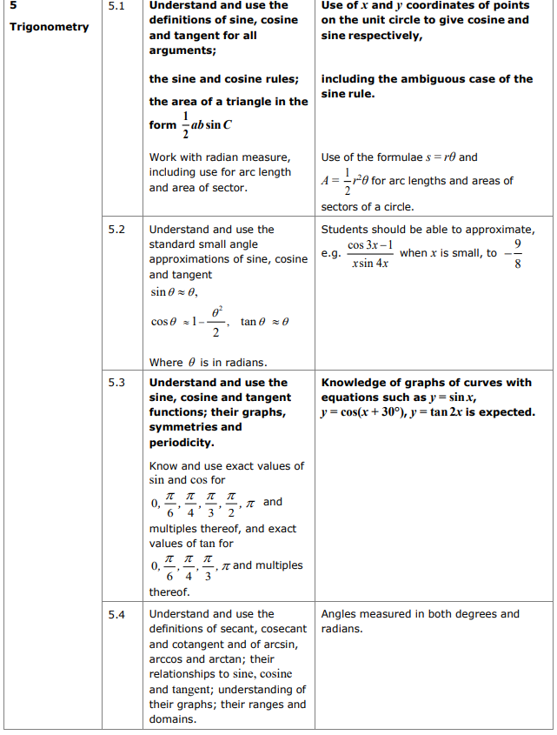
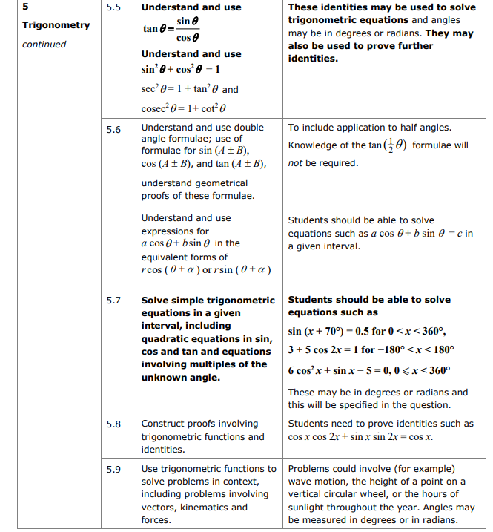

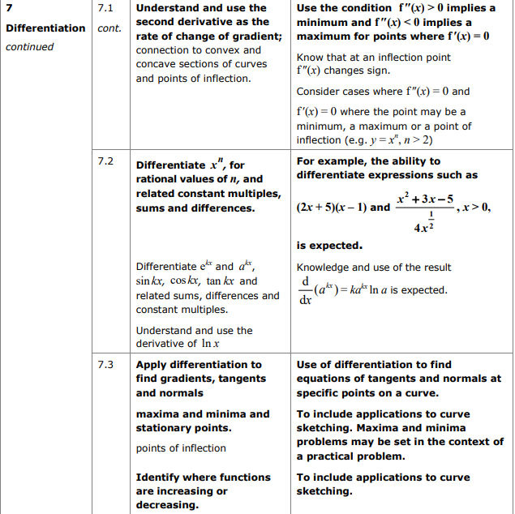
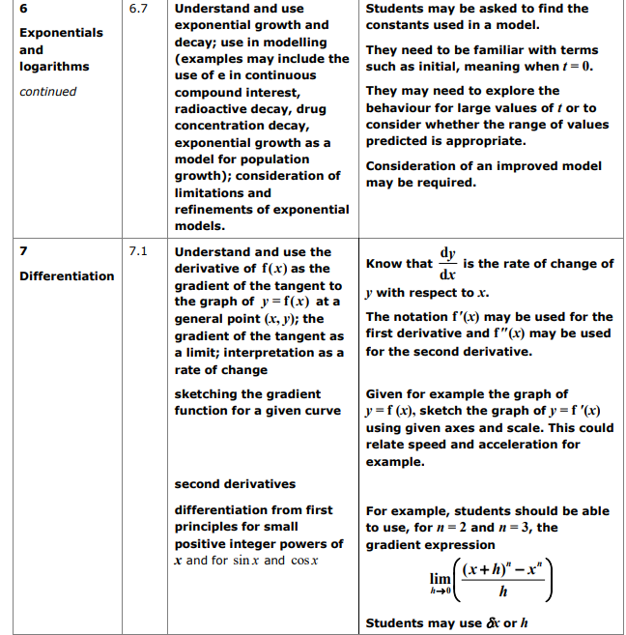

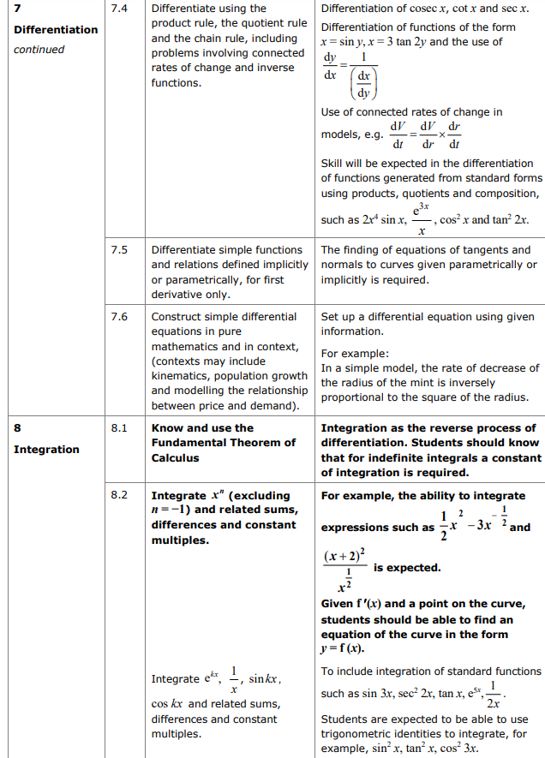
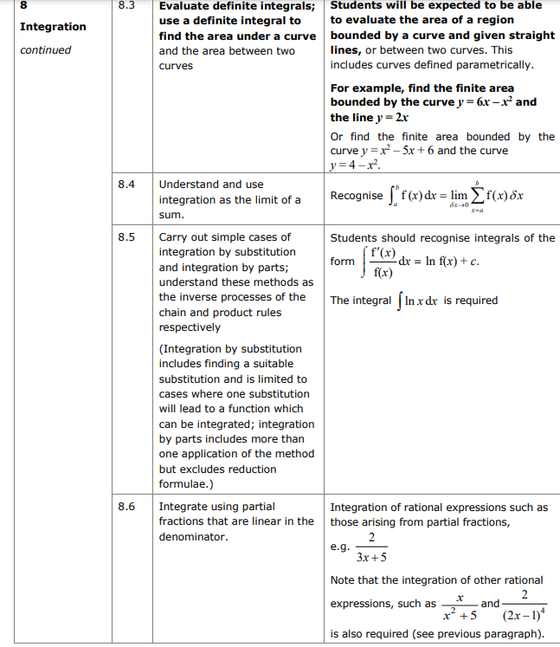

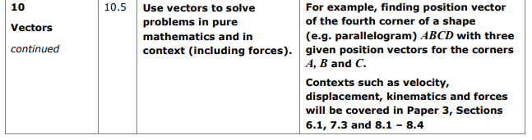
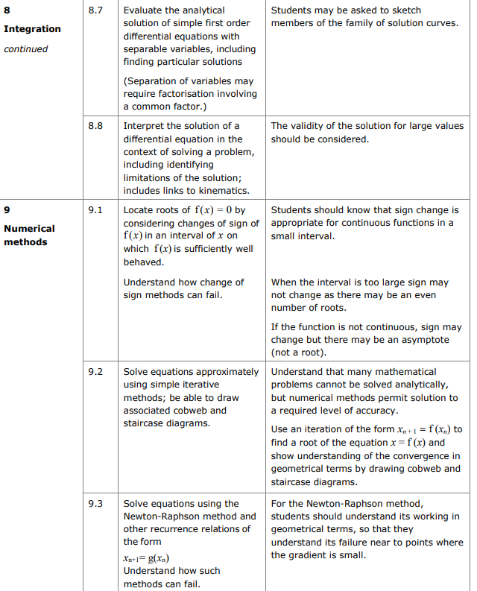
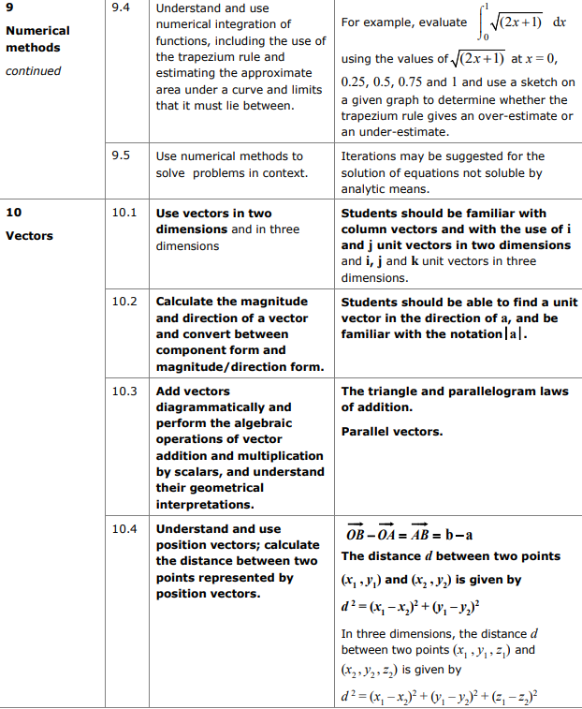

What do I need to revise for Statistics?

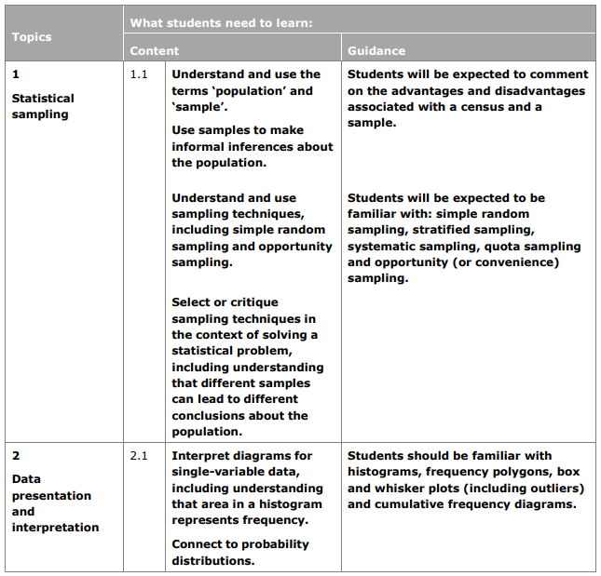
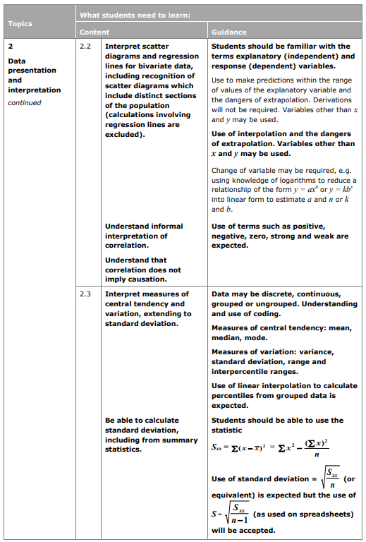
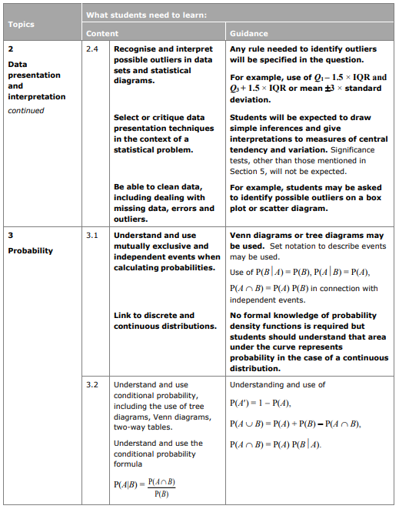
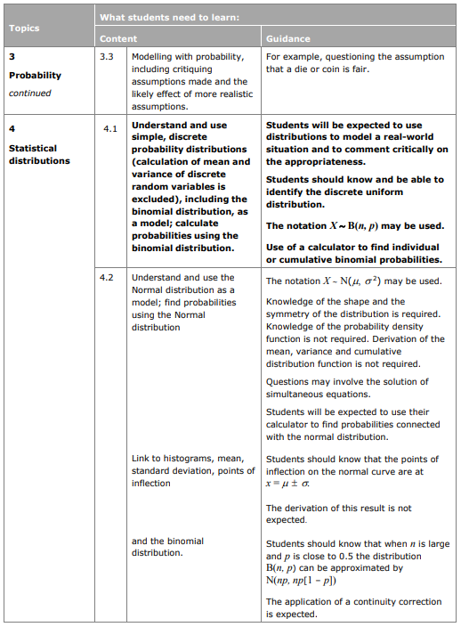
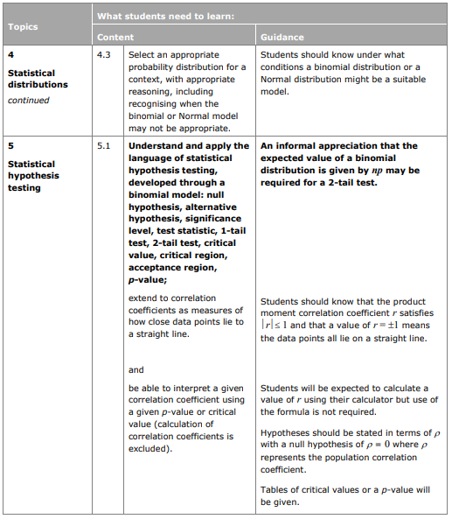
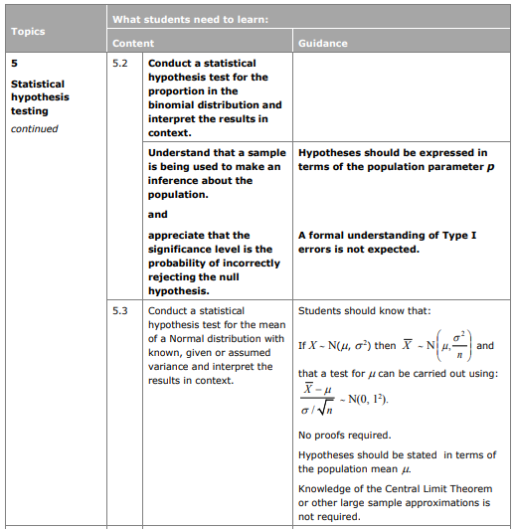

You will need an advanced scientific calculator such as the Casio Classwiz fx-991ex and be able to use it for calculating means, standard deviations and regression and correlation coefficients, and for calculating probabilities with the binomial and normal distributions.

What do I need to revise for Mechanics?

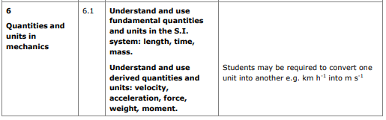
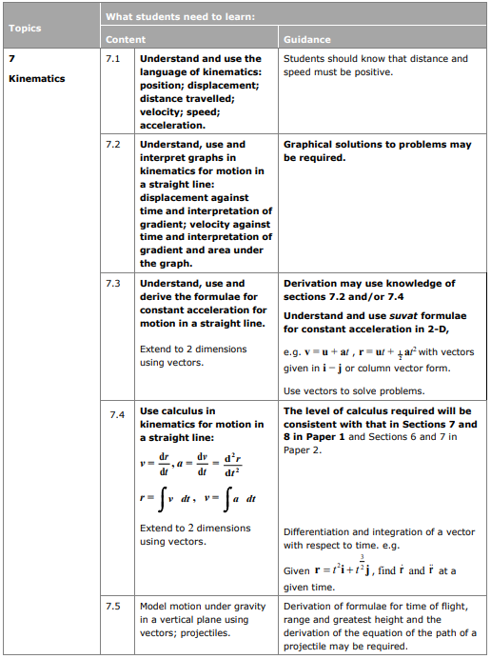
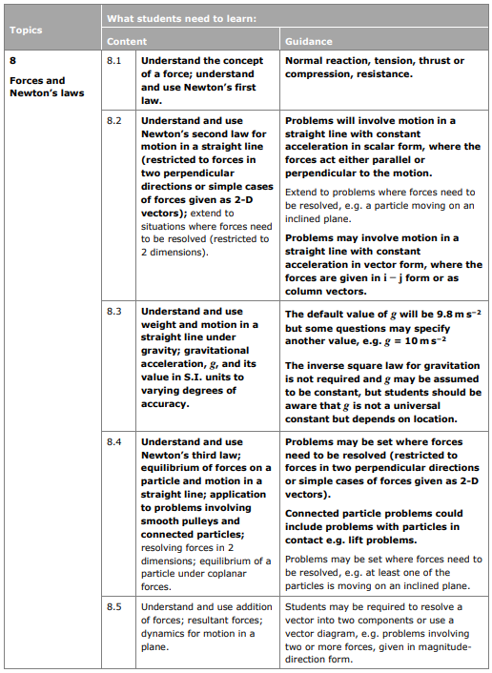
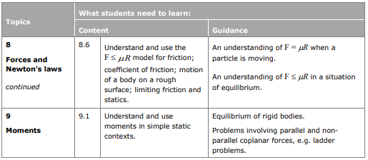

Support available in school.
Additional support is available in school at the following times:
Pure interventions:
Every Monday P6 (1 hour) – Pure drop in sessions
Every Tuesday P6 (1 hour) – Pure drop in sessions

Applied interventions:
Every Wednesday P0 (30mins) – Statistics drop in sessions
Mechanics will be arranged when necessary

