Revision Guidance

CONTENTS PAGE

The course outline | p.2
Textbooks and revision guides | p.2
Paper 1: Thematic Study & historic environment | p.3
Paper 2: Period Study & British Depth Study | p.4
Paper 3: Modern Depth Study | p.5
Revision Strategies | p.6
Exam Skills and Questions | p.7
Revision Plan (Lessons and independent study) | p.8

Course Details

The specification you are studying is history 9-1 with examination board Edexcel and the qualification is made up of three different units:
Paper Title | Topics | Length/ Time | Marks | Worth | Date
Paper 1 | Thematic Study and historic environment: Medicine in Britain, c.1250 to present and the British sector of the Western Front | 1 hour and 15 minutes | 52 | 30% of your final grade | Thursday 19^{h} May (am)
Paper 2 | Period study: Superpower relations and the Cold War, 1941-91 (not examined in 2021)  British Depth study: Early Elizabethan England | 1 hour and 45 minutes (55 mins 2021) | 64 (32 in 2021) | 40% (20% each topic) of your final grade | Tuesday 16th June (am)
Paper 3 | Modern Depth Study: Weimar and Nazi Germany | 1 hour and 20 minutes | 52 | 30% of your final grade | Tuesday 9th June (am)

Textbooks and Revision Guides
In the first instance, we would encourage students to utilise their workbooks and material via Show My Homework, Moodle or Oak Academy to revise. However, you may wish to buy your own textbook to support your revision. These are all available on Amazon.co.uk at £6.49 each:

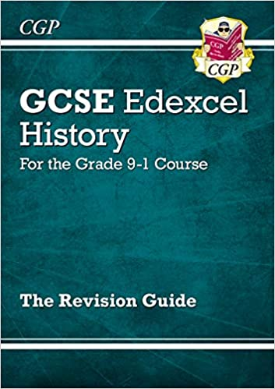
Other options are topic-specific booklets, model answer booklets and flashcards, all found on Amazon.co.uk or second hand on Ebay. A fantastic website is: http://www.stchistory.com/
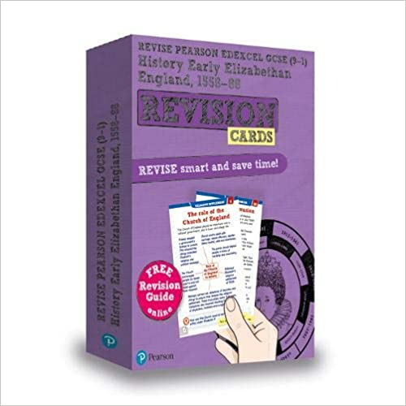
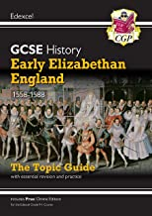

Paper 1:
Thematic study and historic environment

What do I need to revise for Paper 1?
Section A: THEMATIC STUDY | Section B: BRITISH DEPTH STUDY

Paper 2:
British Depth study and Period study

What do I need to revise for Unit 2?
Section A: BRITISH DEPTH STUDY | Section B: PERIOD STUDY

Paper 3:
Modern depth study

What do I need to revise for Unit 3?

Revision Strategies:
Your history exam is based on the following skills:
- Knowledge & understanding
- Explain
- Analyse sources/interpretations
- Form judgements
- SPaG
Revision strategies that help with these skills:
Knowledge & understanding (remembering facts!) | - Flashcards  - Testing a partner  - Post-it notes  - Quizzes on Show My Homework  - Make a 3D Model  - Make up a comical rhyme or mnemonic
Explain | - Work with the information – draw it/ say it)  - Mind maps (link ideas together)  - Asking yourself – ‘so what?’  - Practice exam questions  - Make your own exam questions!
Analyse sources | - Annotating sources  - Practising on everyday sources of information e.g. a TV advert / poster – what does it tell us? It is accurate/reliable?  - Using a piece of paper to cover parts of the source so you are focusing on this  - Use tables to make a plan (especially with the 15 marker – accuracy/reliability!)
Forming judgements | - Balancing arguments in a table  - A debate with your friends!
SPaG | - Writing out key terms, covering and testing your spellings  - Playing games (e.g. Bingo/scrabble/crosswords) with key terms

Exam Skills and Questions:
Skills:
AO1 Understanding & Knowledge | Clear points with specific, detailed evidence
AO2 Explain / analyse | Explain points & linking back to the question using historical concepts (significance, change/continuity, similarity/difference, interpretation, cause/consequence)
AO3 Analyse sources | Make clear inferences (what you can see) from a source, explain how useful a source is referring to TAP (time, author, purpose)
AO4 Analyse interpretations | Say how/why interpretations differ (TAP/type), Say how far you agree with an interpretation
Written communication | Write in full sentences & clearly structured paragraphs, use key entitlement vocabulary
Exam questions:
Paper 1 - Medicine Through Time Section A
[4] Describe two features of… |  | AO1
[8] How useful are Sources A and B for an enquiry into… |  | AO3
[4] How could you follow up Source A to find out more about… |  | AO3
Paper 1 - Medicine Through Time Section B /
Paper 2 – Early Elizabethan England
[4] Explain one way in which ___ changed in ___ time period. (Medicine) |  | AO1/AO2
[4] Describe two features of… (Normans) |  | AO1
[12] Explain why… |  | AO1/AO2
[16 + 4 SPAG] ‘____’ How far do you agree? |  | AO1/AO2
Paper 3 – Weimar and Nazi Germany
[4] Give two things you can infer from Source A about… |  | AO3
[12] Explain why… |  | AO1/AO2
[4] What is the main difference between interpretation 1 and 2 about… |  | AO4
[4] Give one reason why interpretations 1 and 2 differ about… |  | AO4
[16 + 4 SPAG] How far do you agree with interpretation _ about… |  | AO4

